# **INTRODUCTION**

# **CHAPTER 1**

**INTRODUCTION**

Cardiovascular disease (CVD) is increasing day by day in this modern world. According to WHO, an estimated 17 million people die of CVDs particularly heart attack and strokes, every year [1]. Thus, it is necessary to enlist the most important symptoms and health habits which contribute towards CVDs.

Different tests are conducted before diagnosing CVD ,Some of them are below

ECG, blood pressure, cholesterol and blood sugar. These tests are often extensive and time consuming while a patient’s health condition may be critical and he/she needs to start immediate medication so it becomes important to prioritize the tests. There are several health habits which contribute to CVDs so that healthy habits can be practised

Machine learning is an emerging field today due to a rise in the amount of data. Ma- chine learning helps to gain insight from a massive amount of data which is very cum- bersome to humans and sometimes also impossible. The study’s objective is to priori- tize the diagnosis test and see some of the health habits which contribute to CVD. Fur-theremore, and most importantly, different machine learning algorithms are compared according to different performance metrics. In this thesis, manually classified data is used. Manual classification is either healthy or unhealthy. Based on a machine learning technique called classification, 70 percent data are supervised or trained and 30 per- cent are tested in this thesis. Thus, different algorithms are compared as per their pre- diction results.

**THEORETICAL BACKGROUND**

**CHAPTER 2**

**THEORETICAL BACKGROUND**

## **2.1 Overview of Machine Learning**

Machine learning is a subfield of computer science and a rapidly up surging topic in today’s context and is expected to boom more in coming days. Our world is flooded with data and data is being created rapidly every day all around the world. According to Big Data and Analytics Solutions company CSC, it is expected by 2020, that the data amount will be 44 times bigger than in 2009 [2]. Therefore, it is necessary to under- stand data and gain insights for better understanding of a human world. The data amount is so huge today that traditional methods cannot be used. Analysing data or building predictive models manually is almost impossible in some scenarios and also time consuming and less productive. Machine learning, on other hand, produces relia- ble, repeatable results and learns from earlier computation.

Data used for machine learning are basically of two types labelled and unlabelled data.Labelled data is the data where attributes areprovided.Unlabelled data is the data where there are only data points and no labelling to assist.

The labelled data and unlabelled data are used with supervised learning and unsuper- vised learning respectively. Supervised learning entails a learning map between a set of input variables X and an output variable Y and applying this mapping to predict the output for unseen data [3]. After learning the dataset, algorithms generalise the data and formulates the hypothetical value H for the given dataset.

Supervised learning is further categorised into two types: Regression and Classifica- tion. According to the business dictionary, a regression is a technique for determining the statistical relationship between two or more variables where a change in dependent variable is associated with, and depends on a change in one or more independent var- iables [4].

Classification is a taskthat occurs very frequently in everyday life. Essential- ly it involves dividing up objects so that each is assigned to one of a number of mutual- ly exhaustive and exclusive categories known as classes. The term ‘mutually exhaus- tive and exclusive’ simply means that each object must be assigned to precisely one class, i.e. never to more than one and never to no class at all [5,5].

Unsupervised learning studies how systems can learn to represent particular input pat- terns in a way that reflects the statistical structure of the overall collection of input pat- terns. By contrast, with supervised learning there are no explicit target outputs or envi- ronmental evaluations associated with each input; rather the unsupervised learner brings prior biases as to what aspects of the structure of the input should be captured in the output. [6, 858]

## **2.2 Dimension Reduction Techniques**

Dimensionality reduction is simply the process of decreasing the number of input ran- dom variables without the loss of information. A greater number of input variables or dimensions and large data samples increase the complexity of the dataset. To reduce the memory and computational time dimensionality of data is reduced. Dimensionality reduction also helps to eliminate unnecessary input variables like duplicate variables or variables with a very low significance level. [7, 109-110]

There are two types of dimensionality reduction techniques: Feature Selection and Feature Extraction are described below.

### **2.2.1 Feature Selection**

In feature selection, k dimensions are selected out of d dimensions that gives most information and discard the (d-k) dimensions. In other words, feature selection is also called subset selection. The best subset contains the least number of dimensions that contribute most to the accuracy. The best subset is found with suitable error function.

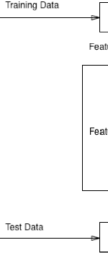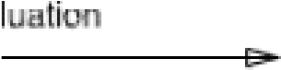

**Figure 1: Feature Selection. Adapted from Md RahatHossian (2013) [8]**

In Figure 1, Training data is put through a certain process of subset generation, for example sequential backward selection. The resulting subset is now put through the algorithm to test its performance if the performance meets the expected criteria, then it will be selected as the final subset. Otherwise, the resulting subset will again be put through the process of subset generation for more fine-tuning.

There are two different approaches to feature selection: Sequential Forward Selection and Sequential Backward Selection which are explained below.

**2.2.1.1 Sequential Forward Selection**

Sequential Forward Selection begins with a model containing no predictors, and then predictors are added to the model, one at a time, until all of the predictors are in the model. In particular, at each step the variable that gives the greatest additional im- provement to the fit is added to the model [9,207].

Let us denote a set by P, with variables Xi, i = 1,……,d. E(P) is the error incurred in the test sample. Sequential Forward Selection starts with empty set with no variables P = {}. At each step, a single variable is added to the empty set and a model is trained, and error E(P Xi) is calculated on test set. Error criteria is set as per requirement, for example, the least square error and misclassification error. From all the errors, the in- put variable causing the least error Xj, is selected and added to the empty set P. The model is trained again with remaining number of variables and the process continues to add variables to P, if E(P Xi) is less than E(P).

**2.2.1.2 Sequential Backward Selection**

Sequential Backward Selection is an efficient alternative for best subset solution but it begins with full set of features unlike Sequential Forward Selection. It removes the least significant features one at a time iteratively. [9,207.]

Sequential Backward Selection starts with a full set of variables P = {1,2,3,…..,d}. At each step, the model is trained with a full set of variables and the error is calculated in test set, and the variable with highest error Xj, is removed from the set P. The model is trained again with a new set of variables P, and the process continues to remove vari- ables from P, if E(P-Xj) is less than E(P).

### **2.2.2 Feature Extraction**

In the feature extraction technique, features or independent variables from the data set are transformed into new independent variables known as new feature space. Newly constructed feature space explains the data most and only significant data are select- ed.

Let, there are n features of X1…….Xn. After feature extraction there are m attributes where (n > m) and this feature extraction is done with some mapping function, F.

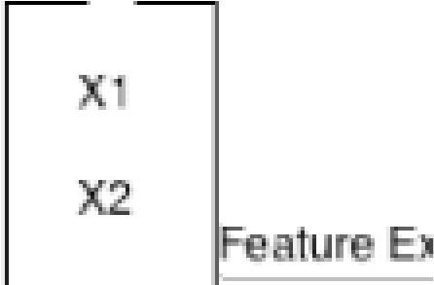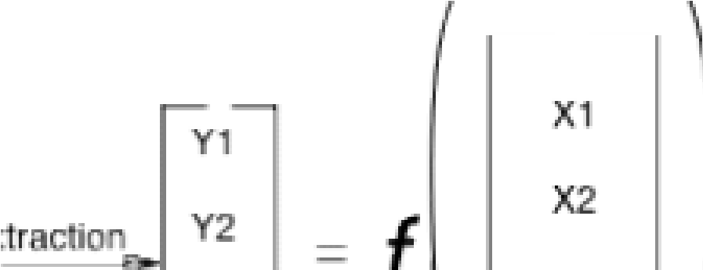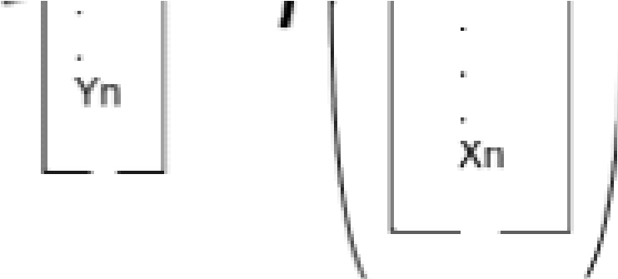

**Figure 2: Feature Extractipon**

Referring to Figure 2, Xn set of independent features or dimensions are reduced to Yn set of independent features. In the feature extraction process, a technique such as principal component analysis is used. It will take only non-redundant and significant features from Xn and change into new feature space Yn [11]. With the feature extrac- tion, capability of interpretation is lost since, Yn features obtained after feature extrac- tion is not same as Xn meaning it is not a direct subset of Xn.

## **2.3 Machine Learning Algorithms**

For the purpose of comparative analysis, six Machine Learning algorithms are dis- cussed. The different Machine Learning (ML) algorithms are k-Nearest Neighbour (KNN), Random Forest (RF), Support Vector Machine (SVM), AdaBoost, Naïve Bayes and Artificial Neural Network (ANN). The reason to choose these algorithms is based on their popularity [12].

### **2.3.1 k-Nearest Neighbour**

Nearest Neighbour algorithms are among the simplest of all machine learning algorithms. The idea is to memorize the training set and then to predict the label of any new instance on the basis of the labels of its closest neighbours in the training set. The rationale behind such a method is based on the assumption that the features that are used to describe the domain points are relevant to their labelling in a way that makes close-by points likely to have the same label. Furthermore, in some situations, even when the training set is immense, finding a nearest neighbour can be done extremely fast.

Mathematically, 𝜌: 𝑋 ∗ 𝑋 → ℝ where Ψ is a function that returns the distance between the two points of 𝑋 (𝑥+, 𝑥+-). The Euclidean distance between two points can be calcu- lated by following formula:

𝜌

𝑥

,

𝑥

-

=

𝑥

−

𝑥

-

=

2

𝑥

+

−

𝑥

-

+

1

+

3

4

k in the k-nearest neighbour is the number of the data points closest to the new in- stance. For example, if k =1 then the algorithm will choose the nearest one instance or if k = 4, then the algorithm will choose the closest four neighbour instances and will classify them accordingly.The idea can be better illustrated with figure 3.

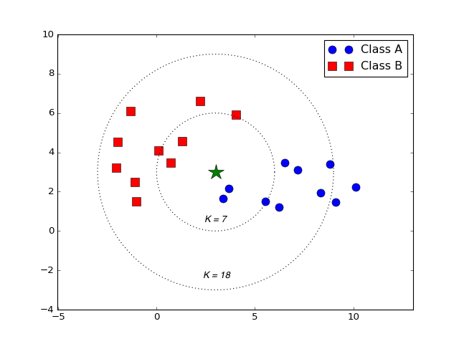

**Figure 3: k- Nearest Neighbour. Modified from K Nearest Neighbour and Dynamic Time Wrapping (2016) [14]**

Referring to Figure 3, Green star is the data point to be classified, blue circles are class A data points and red squares are class B rectangles. The Euclidean distance between the green star and all other red and blue points are measured. The star will be classi- fied to the data points which have least distance. If k =7, then distance between all the seven points are measured from the star and star will be classified to the data points with least distance, in this case with blue data point.

### **2.3.2 Random Forest**

A random forest is a classifier consisting of a collection of decision trees, where each tree is constructed by applying an algorithm A on the training set S and an additional random vector,  where  is sampled i.i.d.(independently and identically distributed) from some distribution. The prediction of the random forest is obtained by a majority vote over the predictions of the individual trees [13,255].

The Random Forest algorithm works in following steps:

1. Picks random K data points from the training data.
2. Builds a decision tree for these K data points.
3. Chooses the Ntree subset from the trees and performs step 1 and step 2
4. Decides the category or result on the basis of the majority of votes.

To understand Random Forest more intuitively it is better to understand decision trees and they can be better understood with the help of a diagram.

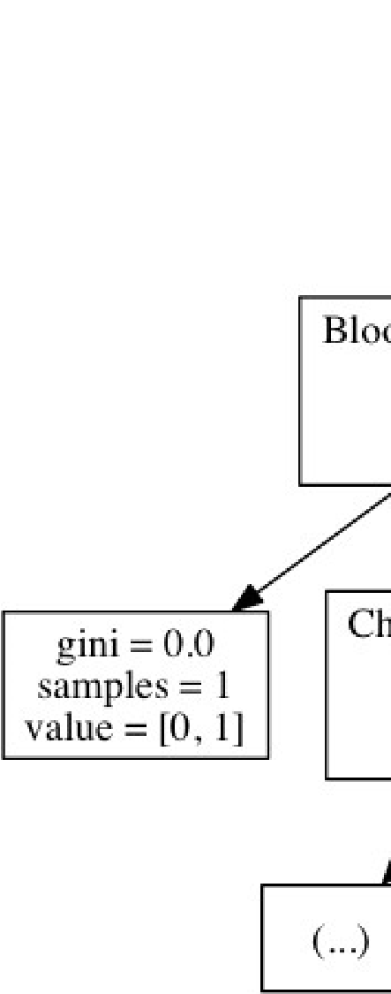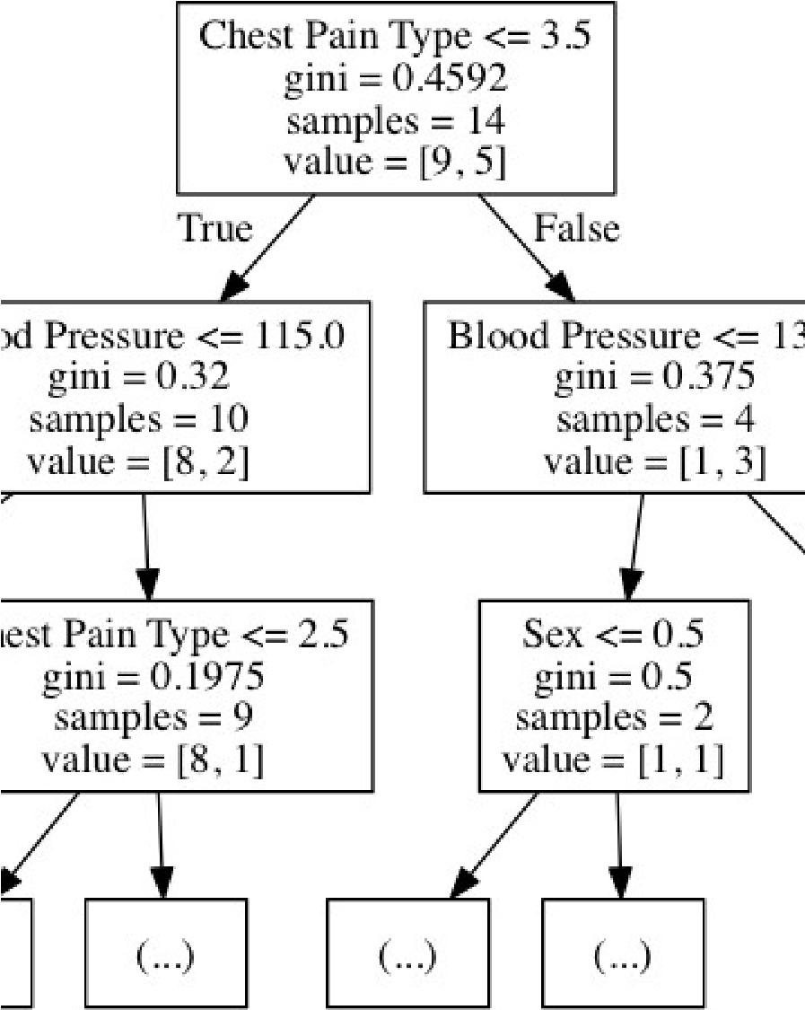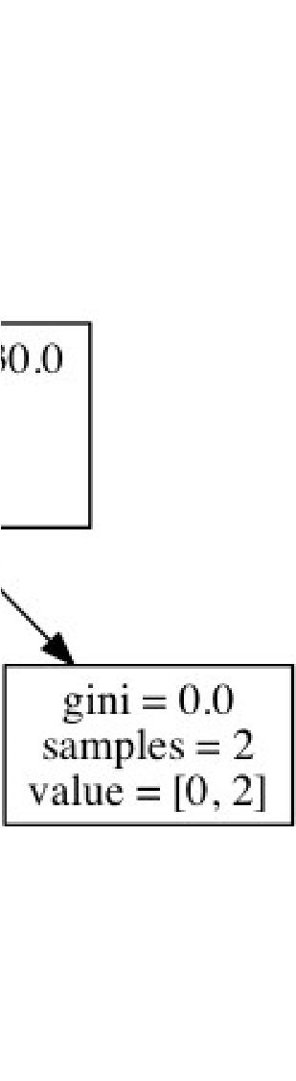

**Figure 4: Random Forest Schematic.**

Referring to Figure 4, it illustrates how decision trees work. If decision trees are used to predict whether there is a heart disease or not, then it will decide according to the above mapping. Gini is the coefficient of the spread of the data, samples are the num- ber of data taken for classifying the node, value is the array of samples which are clas- sified as true or false.

### **2.3.3 Support Vector Machine (SVM)**

A Support Vector Machine (SVM) is a classifier which distinct the various classes of data by the use of a hyper-plane. SVM is modelled with the training data and it outputs the hyper-plane in the test data. [15]. The SVM model tries to find the space in the ma- trix of data where different classes of data can be widely differentiated and draws a

hyper-plane.

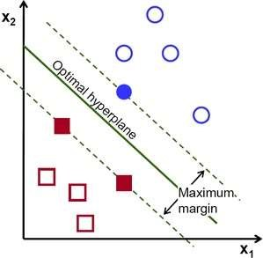

**Figure 5: Support Vector Machine. Reprinted from Introduction to SVM [15]**

In Figure 5, Red and Blue are the classes of labelled training data points. To classify them linearly a hyper-plane can be drawn but the question is: There is more than one way to draw a hyper-plane so which one is optimal? An optimal hyper-plane is chosen which maximizes the margin between the classes. Hyper-plane need not always be linear. A hyper-plane in SVM can also work as a non-linear classifier using technique known as kernel-trick.

### **2.3.4 Naïve Bayes**

Naïve Bayes or Naïve Bayes classifier in a machine learning context is a classifier which uses the Bayes theorem to classify the data and it assumes that the probability of certain feature X is totally independent of another feature Y [7,397]. Bayes theorem can be easily explained with the following example.

Probability of spanners produced by machine A is 0.6, machine B is 0.4. A defect in spanners in the whole of production is 1 percent and the probability of defected span- ners produced by machine A is 50 percent and machine B is 50 percent. In this scenar- io Bayes theorem can be used to answer what is the probability of a defected machine produced by machine B is ?

Bayes theorem provides a way to calculate the probability of the hypothesis given that there is prior knowledge about the problem.

There are three types of Naïve Bayes. Gaussian Naïve Bayes, Multinomial Naïve Bayes and Bernoulli Naïve Bayes. Gaussian Naïve Bayes is used in classification prob- lems, Multinomial Naïve Bayes is used in multinomial distributed data and Bernoulli Naïve Bayes is used in data with multivariate Bernoulli distribution.

### **2.3.5 Ada Boost**

Ada Boost is the one of the robust techniques proposed by Freund and Schapire and most practical and widely used boosting algorithm [16]. Boosting is an ensemble tech- nique in machine learning used for creating highly accurate predictions or strong classi- fier from relatively weak and inaccurate classifiers. Boosting is an iterative process where a model is trained in data and finds weak learners. The second model is trained in data which learns from the mistakes of previous training and fixes the errors and the process continues until the training data is correctly predicted.

Let the number of training samples be 20 in a binary classification problem and training samples be uniformly distributed, D1, initial weight of each sample w is 1/20. After the training samples are trained in a model G1, 5 of them are misclassified. Therefore, error rate e = 0.25, the weight of model G1 is

Misclassified samples are weighted more by multiplying with 𝑒TS and correctly classi- fied samples are weighted less by multiplying with 𝑒QTS and all weights are normalized to 1. Now, the second model is trained G2 and the same process continues until opti- mum samples are correctly classified and final model is the sum of all weighted models as shown in Figure 6.

Schematic of Adaboost is illustrated below.

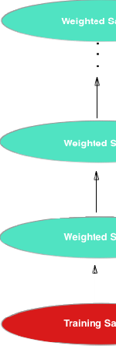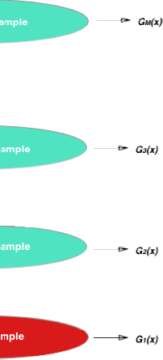

**Figure 6: Adaboost Schematics. Adapted from Trevor Hastie (2001) [17,338]**

In Figure 6, training sample is the first set of independent predictor variables which are to be modelled. After the modelling error rate is achieved and weak learners are identi- fied. These newly achieved weak learners are weighted and weighted samples are again modelled and this process continues up to M number of times and finally all the outputs from different samples are averaged to give boosted output.

### **2.3.6 Artificial Neural Network**

Artificial Neural Network is modelled after biological neural networks and attempts to allow computers to learn in manners similar to human-reinforcement learning [18]. The basic unit in neural network which operates in known as perceptron. A perceptron con- sists of one or more inputs, a processor, and a single output. A perceptron follows the “feed-forward” model, meaning the inputs are sent to a neuron, processed and result in output.

A perceptron follows four main steps.

1. Receive inputs
2. Weight inputs
3. Sum inputs
4. Generate inputs

Each input that is sent into the neuron must first be weighted, i.e. multiplied by some value (often a number between -1 and 1). Creating a perceptron typically begins by assigning random weights. Each input is taken and multiplied by its weight. The output of the perceptron is generated by passing that sum through an activation function. In the case of a simple binary output, the activation function is what tells the perceptron whether to “fire” or not. Many activation functions to choose from (Logistic, Trigonomet- ric, Step etc.). For example, let us make the activation function the sign of sum. In other words, if the sum is positive number, the output is 1; if it is negative, the output is -1. One more factor to consider is bias. Imagine both inputs were equal to zero, then any sum no matter what multiplicative weight would also be zero.

To avoid the problem, a third input is added known as bias input with a value of 1. This avoids the zero issue.

To actually train the perceptron following steps are used:

1. Provide the perceptron with inputs for which there is a known answer.
2. Ask the perceptron guess for an answer.
3. Compute the error (How far off from the correct answer?)
4. Adjust all the weights according to the error, return to step 1 and repeat.

We repeat this until we reach the error we are satisfied with. That is how a single per- ceptron would work. Now to create a neural network all that is needed is to link many perceptrons together in layers, input layer and output layer. Any layers in between input and output layer are known as hidden layers.

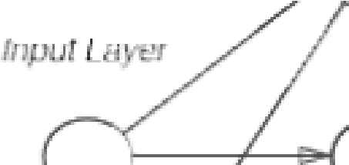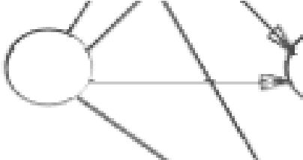

**Figure 7: Schematic of Artificial Neural Network**

In Figure 7, a perceptron consists of one input layer, two hidden layer and one output layer.

## **2.4 Performance Metrics**

In a machine learning context, performance metrics is the measurement of algorithm on how well algorithm performs based on different criteria such as accuracy, precision, recall etc. Different performance metrics are discussed below.

Confusion Matrix

Confusion matrix is a technique to show how the classifier is confused while predict- ing. In a binary classification problem, the confusion matrix is often illustrated as below.

|  |  |  |  |  |
| --- | --- | --- | --- | --- |
| Correct classification |  | Class | ified as |  |
|  | + (1) |  | - (0) |
| + (1) | TP (1,1) |  | FN (1,0) |  |
| - (0) | FP(0, 1) |  | TN(0,0) |  |

**Table 1: Confusion Matrix**

In Table 1, TP is the true positive value which means the positive value is truly classi- fied, FP is the false positive value which means positive value which is falsely classi- fied, FN is the false negative value which means negative value which is falsely classi- fied and TN is the true negative which means negative value which is truly classified.

From the confusion matrix, different performance metrics can be calculated. Using Ta- ble 1 as an example, accuracy, precision, recall and F1-score are explained in more detail below.

Accuracy

Accuracy or predictive accuracy is the measure of the proportion of instances that are correctly classified [5, 178]. It shows how close the predicted value is to the true value or the theoretical value. Formula for calculating the accuracy is given below.

Accuracy is the measure of how close or near the predicted value is to the actual or theoretical value. For example, if the actual value of a person’s height is 6 feet and measured value or predicted value is 5.9 then it is quite an accurate measurement.

**Precision :**

Precision is defined as the proportion of true positive instances which are classified as positive [5, 178]. It shows how close predicted values are to each other. Formula for calculating precision is given below.

Precision is the measure of how close or near the predicted values are to each other. For example, if actual value of person’s height is 6 feet and measured value is or pre- dicted value is 5.5 and every time measurement is taken height is 5.4 or 5.6 then pre- diction is quite precise but not accurate.

**Recall :**

Recall is defined as the proportion of positive instances are that correctly classified as positive [5,178]. Recall is also often called sensitivity. Formula for calculating recall is given below.

Recall is simply the measure of how many true samples are predicted from the all the samples.

F1 score is defined as the measure which combines both precision and recall and tries to convey the balance between them. Formula for calculating F1 score is given below.

F1 score shows how good the classifier is in the context of both precision and recall. Therefore, it is good to have both precision and recall value be more to have better F1 score. Either precision or recall value is low than the overall F1 score decreases.

**ROC Curve :**

ROC Curve, Receiver Operating Characteristic is a graphical way to show how good the performance of a classifier is. Basically, it is a plot of a true positive rate against a false positive rate.

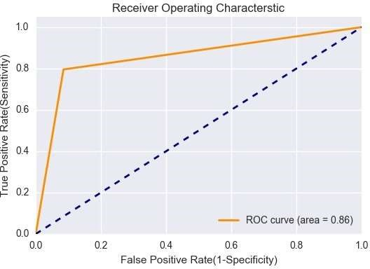

**Figure 8: ROC Curve**

In Figure 8, orange line represents the true positive rate the classifier has achieved, the dotted line is a random line which classifies the data in two halves. When the orange line goes below the dotted lines it means the classifier is worse than random guessing and as the orange line goes above the classifier is good. If orange line reaches the value of 1 in Y-axis than that is perfect classifier.

Area covered below the orange line is called Area Under the Curve, AUC, which means, larger the area under covered by the curve better is the classifier. Maximum value is 1 and anything more than 0.90 is considered excellent. Simultaneously, 80 to 90, 70 to 80, 60 to 70 and 50 to 60 are good, fair, poor and fail [19].

**Cross Entropy :**

Cross Entropy is the name commonly used when the classification is not binary and a log loss is used when classification is binary. Underlying mathematics for both cross entropy and log loss is same. A log loss is defined as “negative log-likelihood of the true labels given a probabilistic classifier’s prediction” [20]. Log loss quantifies the ac- curacy of classifier by penalising false classification. It means log loss maximizes the accuracy of classifier, therefore lower the log loss better is the classifier. Log loss is often used in competition like Kaggle to evaluate the accuracy of the model. Formula for log loss is given below.

## **2.5 Probability Calibration**

Probability calibration is a classifier which outputs class probabilities rather than the class labels. To have some confidence in the predicted output it is sometime better to know the probability of the predicted class. However not all the classifiers do support the probability output and some of the gives poor results in probability output. So be- fore comparing the classifiers, it is better to calibrate.[21]

There exists a special curve named as reliability curve which helps to find out which of the classifiers need to be calibrated. In the reliability curve, classifier having a plot near to diagonal is well calibrated and vice-versa. Classifiers which are way off the diagonal line need to be calibrated.

There are two types of calibration used in probability calibration named Platt Scaling and Isotonic Regression. These two methods are designed for binary classification and it does not work for multiclass problems. One way to use these methods in multiclass problem is to change multiclass problems into binary classification. Platt calibration is simply obtained by passing the classifier through special function called sigmoid function and Isotonic calibration is obtained by passing the predicted output or mapping the predicted output through monotonically increasing function.

In the reliability diagram above, the logistic regression curve is very close to perfectly calibrated line which is a diagonal. It means logistic classifier needs not be calibrated while the Support Vector Machine curve is distorted from diagonal, it means SVM gives very poor estimates of the predicted probabilities and needs to be calibrated.

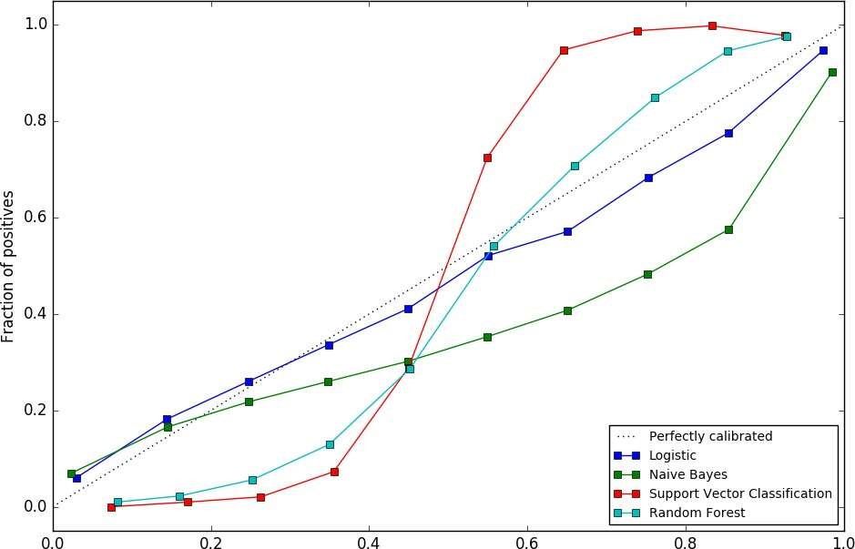

**Figure 9 : Reliability Curve. Reprinted from Probability calibration**

## **2.6 Data Pre-processing**

In the modern world, there is a large amount of data collected through various sources such as the internet, surveys and experiments etc. But most of the time the data to be used are full of missing values, noises and distortions.

Since, majority of data collected are not taken fromcontrolled environment, the data can contain garbage in it. “Garbage in – Garbage out” principles work here also. No matter how well data is modelled, if data contains garbage then output obtained is always garbage. Therefore, data pre- processing is a fundamental step to data analysis and machine learning. Data pre- processing or often called data wrangling is a set of procedures which transforms raw data into understandable format.

Data pre-processing includes detecting outliers, making decisions what to do with the outliers, finding and filling appropriate missing values and searching for inconsistency in the data. Data needs to normalized or standardized and reduced before applying to machine learning algorithms. Normalization of data is done when the features of da- taset have different measuring units. For example, Fahrenheit and Celsius, though both are units of temperature their measuring units are different. Standardization is used to scale the data and it gives the information on how many standard deviations the data is from its mean value. Standardization rescales the data to have the mean () of 0 and the standard deviation . Data is reduced, also known as feature selection when there are redundant features in the dataset or the features are very insignificant for the results.

# **METHODS AND MATERIALS**

**CHAPTER 3**

**METHODS AND MATERIALS**

## **Methods and Materials :**

This section describes the different methods and materials used for this study i.e., re- search approach, research design and implementation, data collection and tools used for this study.

## **3.1 Research Approach**

This thesis examines the empirical relationship between the set of features such as age, sex and blood pressure with the probability of being diagnosed with heart disease Therefore, this thesis is a quantitative case study.

Researcher Robert K. Yin defines “a case study as an empirical inquiry that investigates a contemporary phenomenon within its real-life context; when the boundaries between phenomenon and context are not clearly evident; and in which multiple sources of evidence are used [22].”

Quantitative case study approach [23, and 22] is chosen in this thesis because the idea of this study is to investigate available heart disease datasets using a number of statistical methods and running machine learning algorithms on them, so as to find out which one of the machine learning algorithms give better results. Similar studies have been done in the past. The motive of this study is to replicate and extend the previous studies.

## **3.2 Research Design**

This section illustrates the research design; it describes the actual flow the of the entire research.

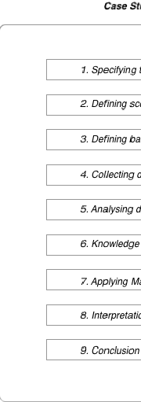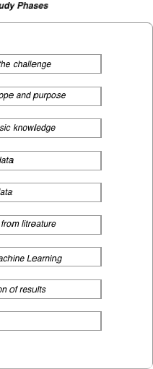

**Figure 10: Flow of the case study**

The first step of this study was to use an available heart disease data set and compare different machine learning algorithms to understand their performance based on differ- ent performance metrics. In the second step, scope for the study and its purpose was defined. The scope of the study was defined as per study purpose, resources and schedule. The studies purpose was to understand the machine learning algorithms behaviour in particular heart disease data sets and to try to infer the results. The re- sources include a computer used for the analysis, this is crucial in defining the scope of the study because computer used defines how much and how fast data can be ana- lysed. Computer used in this study was enough to perform major tasks but not enough for in-depth and optimal results. The schedule is set as per the thesis requirements, which restrict this study to examine algorithms in greater detail.

In the third step,basic knowledge to get started with the research was defined. For that several online resources were used and fundamentals for the study were understood. In fourth step, data was collected online from machine learning repository UCI, Irvine. In the fifth step, descriptive and exploratory data analysis as well as data cleaning was done as per the knowledge gained from step 3.

It helped to understand the data more such as features included, correlation between features, missing values and outliers. In the sixth phase, different literature was studied related to this heart disease data set. The literature was available online and the findings of the literatures were reviewed. In the seventh phase, different machine learning algorithms were trained and the results were obtained as per different performance metrics. In the eighth phase, results were interpreted and com- pared with other existing literature on the subject. In ninth and final phase, conclusions were derived based on the results obtained.

## **3.3 Data Collection and Description**

The data is collected from UCI machine learning repository. The data set is named Heart Disease Data Set and can be found in UCI machine learning repository. The UCI machine learning repository contains vast and varied amount of datasets which include datasets from various domains. These data are widely used by machine learning com- munity from novices to experts to understand data empirically. Various academic papers and researches have been conducted using this repository. This repository was created in 1987 by David Aha and fellow students at UCI Irvine. [24] Heart disease data set contains data from four institutions.

1. Cleveland Clinic Foundation.
2. Hungarian Institute of Cardiology, Budapest.
3. V.A. Medical Centre, Long Beach, CA.
4. University Hospital, Zurich, Switzerland.

The UCI machine learning repository contains vast and varied amount of datasets which include datasets from various domains. These data are widely used by machine learning community from novices to experts to understand data empirically.

For the purpose of this study, the data set provided by Cleveland Clinic Foundation is used. This dataset was provided by Robert Detrano, M.D, Ph.D. Reason to choose this dataset is, it has less missing values and is also widely used by research community. [25]

|  |  |
| --- | --- |
| Features | Description |
| Age | Age in years |
| Sex | Gender instance (0 = Female, 1 = Male) |
| Cp | Chest pain type (1: typical angina, 2: atypical angina, 3: non- anginal pain, 4: asymptomatic) |
| Trestbps | Resting blood pressure in mm Hg |
| Chol | Serum cholesterol in mg/dl |
| Fbs | Fasting blood sugar > 120 mg/dl (0 = False, 1= True) |
| Restecg | Resting ECG results (0: normal, 1: ST-T wave abnormality, 2:  LV hypertrophy) |
| Thalach | Maximum heart rate achieved |
| Exang | Exercise induced angina (0: No, 1: Yes) |
| Oldpeak | ST depression induced by exercise relative to rest |
| Slope | Slope of the peak exercise ST segment (1: up-sloping, 2: flat,  3: down-sloping) |
| Ca | Number of major vessels coloured by fluoroscopy (values 0 -  3) |
| Thal | Defect types: value 3: normal, 6: fixed defect, 7: irreversible defect |
| Num | Diagnosis of heart disease (0: Healthy, 1: Unhealthy) |

**Table 2: Features of the Heart Disease dataset**

There are actually 76 attributes in the dataset but only 14 attributes are used for this study, these 14 attributes are in Table 2.

## **3.4 Tools Used**

Different tools are used for this study. All of them are free and open source.

1. Python 3.5
2. NumPy 1.11.3
3. Matplotlib 1.5.3
4. Pandas 0.19.1
5. Seaborn 0.7.1
6. SciPy and Scikit-learn 0.18.1

Python is a high level general programming language and is very widely used in all types of disciplines such as general programming, web development, software development, data analysis, machine learning etc. Python is used for this project because it is very flexible and easy to use and also documentation and community support is very large [26].

NumPy is very powerful package which enables us for scientific computing. It comes with sophisticated functions and is able to perform N-dimensional algebra, Fourier transform etc. NumPy is used very where in data analysis, image processing and also different other libraries are built above NumPy and NumPy acts as a base stack for those libraries [27].

Pandas is open source BSD licensed software specially written for the python programming language. It provides complete set of data analysis tools for python and is best competitor for R programming language. Operations like reading data-frame, reading csv and excel files, slicing,

indexing, merging, handling missing data etc., can be easily performed with Pandas. Most important feature of Pandas is, it can perform time series analysis [28].

Seaborn is library used for data visualization and is created by using python program- ming language. It is high level library stacked on top of matplotlib. Seaborn is more attractive and informative than matplotlib and very easy to use and is tightly integrated with NumPy and Pandas. Seaborn and matplotlib can be used essentially side by side to derive conclusions from the datasets [29].

SciPy is a collection of fundamental mathematical functionsand is built on the top of Numpy while Scikit-learn is widely used popular library for machine learning, it is third party extension to SciPy. Scikit-learn includes all the tools and algorithms needed for most of machine learning tasks. Scikit-learn supports regression, classification, clustering, dimensionality reduction and data pre-processing. For this study, scikit-learn is used because it is based on python and can interoperate to NumPy library. It is also very easy to use [30].

## **3.5 Data Cleaning and Scaling**

The Cleveland dataset used for this study contains 303 rows, 5 numerical and 9 cate- gorical attributes. The data set has 6 missing values. Since the missing values are from categorical attributes it was replaced with mode value of the respective columns. There are 43 outliers in the dataset but it is not a noise or wrong input. Data falling outside the 3 standard deviation are considered outliers. Patients who are diagnosed with heart disease have these outliers, meaning their cholesterol and blood pressure data is above the normal scale. So, in real clinical scenario it is not outlier and therefore it is decided to keep these outliers as they are. Standardization was used to rescale the data. That helped the machine learning models to perform better.

## **3.6 Data Reduction**

For the Cleveland dataset, Sequential Backward Elimination is used. Any features in the data set whose p-value is less than 0.05 is significant and is considereddata set whose p-value is less than 0.05 is significant and is considered essential in this data set.

The logistic model was used as a classifier for sequential backward elimination. Out of 13 dependent attributes 9 attributes are selected by using sequential backward elimination. Data reduced features selected are listed below.

1. Sex
2. Chest pain type (Cp)
3. Resting blood pressure (Trestbps)
4. Maximum heart rate achieved (Thalach)
5. ST depression induced by exercise (Oldpeak)
6. Slope of the peak exercise ST segment (Slope)
7. Number of major vessels coloured by fluoroscopy (Ca)

## **3.7 Descriptive Statistics and Exploratory Data Analysis**

In this section, both descriptive statistics and exploratory data analysis are discussed. Out of 14 attributes, the data contains only five numeric attributes, out of which only four are tabulated below. Oldpeak attribute is excluded from the table because it needs deep understanding of heart physiology to interpret its results.

|  |  |  |  |  |
| --- | --- | --- | --- | --- |
|  | Age | Trestbps | Chol | Thalach |
| mean | 54.43 | 131.68 | 246.69 | 149.60 |
| std | 9.03 | 17.59 | 51.77 | 22.87 |
| min | 29.00 | 94.00 | 126.00 | 71.00 |
| median | 56.00 | 130.00 | 241.00 | 153.00 |
| mode | 58.00 | 120.00 | 197.00 | 162.00 |
| max | 77.00 | 200.00 | 564.00 | 202.00 |

**Table 3: Descriptive statistics of Heart Disease dataset.**

In Table 3.7, the distribution of data is non-symmetrical and skewed. Population of data is 303, whose age range is 29 to 77. Age distribution of data is left skewed which shows population with low age are absent. Mean, median and mode of age column are 54.43, 56.00 and 58.00 respectively. Standard deviation is 9.03 which shows the sparseness of the age, ranging from 53.40 to 64.46, this age range visits the doctor most. Similarly, Trestbps, blood pressure column’s data is right skewed, which shows either population with normal blood pressure is present or there is lack of high blood pressure. Average blood pressure is 131.68 which is slightly above normal blood pres- sure, 120, this shows population is in pre-high blood pressure zone. Minimum blood pressure is 94 which is higher than low blood pressure 90, this shows population has not low blood pressure problems. In Chol, column mean value is 246.69 which mean population has high cholesterol level, cholesterol border line value is from 200 to 239. Mode value is 197.00 which shows most of the population has desirable cholesterol level, which is less than 200. Cholesterol mean value of 246.69 is abnormal in contrast to mode value of 197.

In Thalach, maximum heart rate achieved, mean value is 149.60 with standard deviation of 22.87 with minimum value of 71.00 and maximum value of 202.00 which shows heart beat rate in average is less than normal of 200 beats per minute.

Table 4 shows the correlation of numeric data:

Table 4. Corelation matrix between numeric attributes

|  |  |  |  |  |
| --- | --- | --- | --- | --- |
|  | Age | Trestbps | Chol | Thalach |
| Age | 1.00 | 0.28 | 0.20 | -0.39 |
| Trestbps | 0.28 | 1.00 | 0.13 | -0.04 |
| Chol | 0.20 | 0.13 | 1.00 | -0.003 |
| Thalach | -0.39 | -0.04 | -0.003 | 1.00 |

**Table 4. Corelation matrix between numeric attributes**

From Table 4, it can be concluded that age and maximum heart rate achieved has some correlation. As, age increases, heart rate decreases except that none of other attributes shows any high correlation with each other.

From the exploratory analysis of the data, the following insights are gained. Two of the insights are presented in figure 11.

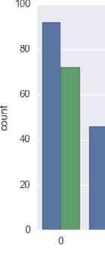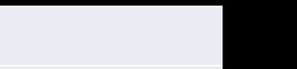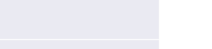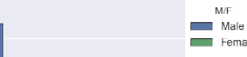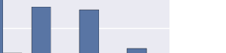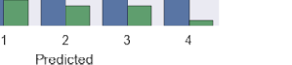

**Figure 11: Disease rate in the male and the female.**

In 4 are the status of heart health ranging from healthy to severely unhealthy. Blue bar represents male population and green bar represents female population. It can be seen that; in this data set the male population is more prone to heart disease. To verify, chi-square test is performed, for that null hypothesis H0 is proposed.

Null hypothesis states that disease has no correlation with population’s gender, if this hypothesis is rejected by chi-square test then, hypothesis H is established which states that disease has some correlation with population’s gender.

|  |  |  |  |  |  |  |
| --- | --- | --- | --- | --- | --- | --- |
|  | 0 | 1 | 2 | 3 | 4 | Total |
| Male | 92 | 46 | 29 | 28 | 11 | 206 |
| Female | 72 | 9 | 7 | 7 | 2 | 97 |
| Total | 164 | 55 | 36 | 35 | 13 | 303 |

**Table 5: Number of diseased patients based on sex.**

In Table 5, the total number of male population is 206 and that of female population is 97. 0,1,2,3,4 are the columns ranging from, no heart disease, to severely unhealthy heart disease, and its total values are 164, 55, 36, 35 and 13 respectively.

|  |  |  |  |  |  |
| --- | --- | --- | --- | --- | --- |
|  | 0 | 1 | 2 | 3 | 4 |
| Male | 111.4 | 37.39 | 24.47 | 23.79 | 8.83 |
| Female | 52.50 | 17.60 | 11.52 | 11.20 | 4.16 |

**Table 6: Expected number of diseased patients based on sex.**

In Table 6, the expected number of diseased patients are calculated. One example of how the expected number is derived for 0 column is as follow:

Male= 206*164/303

=111.4

Formula for calculating chisquare test is,

Table 6, contains five columns 0,1,2,3,4 and two rows male and female. Degrees of freedom for this table is (R-1) *(C-1) where R and C are rows and columns respectively. Therefore, degree of freedom is 4.

The value obtained from the chi-square test is 23.35, which is greater than the value from the chi-square distribution table which is 9.488. Therefore, the null hypothesis is rejected. Hence, it can be stated with 95% confidence that disease has some correla- tion with gender. This concludes, as shown in figure 13, that the male population is more prone to heart disease than female population.

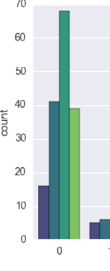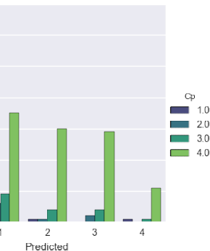

**Figure 12 :Disease prediction according to chest pain type**

In figure 12, in x-axis, there is the predicted value of heart disease ranging 0 to 4 denoting healthy to severely unhealthy.

Cp, chest pain type ranges from 0 to 4 denoting (1: typical angina, 2: atypical angina, 3: non-anginal pain, 4: asymptomatic). In this data set, it can be seen that the population diagnosed with chest pain type 4, asymptomatic chest pain is more likely to have heart disease.

**RESULTS AND DISCUSSION**

**CHAPTER 4**

**RESULTS AND DISCUSSION**

This section deals with the results obtained from the study of Cleveland dataset and also a comparative analysis of algorithms. After all pre-processing, descriptive and ex- ploratory analysis the data set was employed on different machine learning algorithms, also called models.

## **4.1 Overview**

There are two classes found in Scikit-learn machine learning library called LabelEn- coder and OneHotEncoder. LabelEncoder basically transforms the categorical values into numbers which are ordinal in nature. In data set used for this study, there are cat- egorical variables such as Cp, chest pain type which is represented as 1,2,3 and 4. 1,2,3 and 4 does not have ordinal relationship with each other therefore it gives wrong results when applied directly to machine learning algorithms. Thus, One Hot Encder is used to encode chest pain type values into binary values, this resolves the issue of ordinality. In this data set the dependent variable or the value to be predicted is multi class. It ranges from 0 to 4. But for this study, multiclass dependent variable is convert- ed into binary class.

**4.2 Experiments**

In this study initially data set was modelled without feature selection and the results were obtained and in the second phase, data set was modelled only with features obtained from SBS. All experiments included methods like k-fold cross validation and parameter tuning. K-fold cross validation is a technique used in a dataset to avoid over-fitting and under-fitting of the model and parameter tuning is technique which assists to find the best parameters for the model being used.

**4.2.1 Training set**

Training set is the portion of data in which the model is trained. In this study, 70 percent of data was used for training. In general, in machine learning communities, it is a norm to used 60 to 70 percent of data for training but it varies diversely according to the need and purpose of the experiment. In data training, often the accuracy of training is high, meaning the model shows high level of accuracy performance in the training set but when tested against the test set, the performance is poor. So to avoid performance error, k-fold cross validation was used. In k-fold cross validation, for example 10-fold cross validation, training set is split in 10 parts and and from each 10 part, training and test set is defined and model is employed and the result of all the 10 parts are aver- aged, this helps to minimize the over fitting and under fitting of the data.

### **4.2.2 Test set**

The test set is the portion of data where the model is tested, it is often the dependent variable of the data. In this study, 30 percent of the data was used for testing. When cross validated data is tested, it will perform better or worse depending on the model used. So, to ensure every model is functioning in its optimum, a technique named parameter tuning was used. Scikit-learn library contains the class called GridSearchCV which performs the parameter tuning.

### **4.2.3 Results**

The aim of the entire project was to test which algorithm classifies diseases the best. This section includes all the results obtained from the study and introduces the best performer according to various performance metrics.

First, performance was obtained by using 10-fold cross validation in training set. Sec- ondly, performance was obtained just by using model without any parameter tuning, third parameters were tuned and fourth model was calibrated. The following tables shows the results.

|  |  |  |  |  |  |  |
| --- | --- | --- | --- | --- | --- | --- |
| Algorithms used | Accuracy | Precision | Recall | F1-score | ROC  AUC | Log loss |
| KNN | 0.84 | 0.89 | 0.73 | 0.83 | 0.90 | 0.42 |
| SVC | 0.82 | 0.81 | 0.79 | 0.82 | 0.89 | 0.41 |
| Random  Forest | 0.67 | 0.64 | 0.63 | 0.66 | 0.85 | 11.30 |
| Naïve  Bayes | 0.80 | 0.81 | 0.72 | 0.79 | 0.87 | 1.51 |

**Table 7. Evaluation of algorithms in training set using k-fold.**

Referring Table 7, KNN gave best results in the 10-fold cross validation followed by SVC, Naïve Bayes and Random Forest.

Following Table, shows the performance of algorithms in test set without parameter tuning.

|  |  |  |  |  |  |  |
| --- | --- | --- | --- | --- | --- | --- |
| Algorithms used | Accuracy | Precision | Recall | F1-score | ROC  AUC | Log loss |
| KNN | 0.82 | 0.83 | 0.81 | 0.81 | 0.81 | 0.44 |
| SVC | 0.79 | 0.78 | 0.78 | 0.78 | 0.78 | 0.45 |
| Random  Forest | 0.69 | 0.68 | 0.68 | 0.68 | 0.69 | 11.00 |
| Naïve  Bayes | 0.81 | 0.81 | 0.80 | 0.80 | 0.80 | 1.10 |

**Table 8: Evaluation of algorithms in test set without parameter tuning.**

Referring to Table 8, KNN is the best performer followed by Naïve Bayes, SVC and Random Forest. In the test set, Naïve Bayes performed better than in the training set but log loss of Naïve Bayes is high than SVC. It can mean that accuracy of Naïve Bayes classifier is not entirely true, classifier is over fitted.

Table 9, shows the performance of algorithms in test set using parameter tuning.:

|  |  |  |  |  |  |  |
| --- | --- | --- | --- | --- | --- | --- |
| Algorithms used | Accuracy | Precision | Recall | F1-score | ROC  AUC | Log loss |
| KNN | 0.78 | 0.83 | 0.78 | 0.77 | 0.77 | 0.54 |
| SVC | 0.80 | 0.82 | 0.80 | 0.80 | 0.79 | 0.43 |
| Random  Forest | 0.73 | 0.74 | 0.74 | 0.73 | 0.73 | 0.49 |
| Naïve  Bayes | Nil | Nil | Nil | Nil | Nil | Nil |

**Table 9: Evaluation of algorithms in test set using parameter tuning.**

In Table 9, Naïve Bayes’ row is Nil because it does not need parameter tuning, there are no parameters to be tuned in Naïve Bayes. Thus the result from Table 8 was taken for performance comparison. After parameter tuning, KNN performance goes low. SVC, followed by Naïve Bayes and Random Forest are best performer after parameter tuning. In figure 13, performance of log loss is excluded because it is negative in nature and can exceed one in its value, which is not supported by other performance metrics.

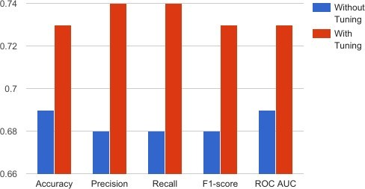

**Figure 13 Random Forest with and without parameter tuning**

In figure 13, Blue bars represents performance without tuning and red bars represents after tuning. It is seen that after parameter tuning random forest performance is much better than before, still its performance is low in this dataset.

Now all of these algorithms are calibrated using Platt’s scaling or also known as sigmoid function. Table 10, shows the results after the calibration.

|  |  |  |  |  |  |  |
| --- | --- | --- | --- | --- | --- | --- |
| Algorithms used | Accuracy | Precision | Recall | F1-score | ROC  AUC | Log loss |
| KNN | 0.78 | 0.78 | 0.78 | 0.78 | 0.77 | 0.46 |
| SVC | 0.79 | 0.80 | 0.79 | 0.79 | 0.78 | 0.43 |
| Random  Forest | 0.75 | 0.73 | 0.73 | 0.72 | 0.72 | 0.5 |
| Naïve  Bayes | 0.80 | 0.81 | 0.80 | 0.80 | 0.79 | 0.48 |

**Table 10, Evaluation of algorithms in test set, parameter tuned using calibration**

In Table 10, after calibration Naïve Bayes outperforms all the algorithms and also log loss of Naïve Bayes has decreased from 1.10 to 0.48. SVC, KNN and Random Forest are the best models respectively.

Table 11, shows the performance of algorithms after they were tuned and calibrated and feature selected using SBS. This helps to compare the model performance before and after feature selection.

|  |  |  |  |  |  |  |
| --- | --- | --- | --- | --- | --- | --- |
| Algorithms used | Accuracy | Precision | Recall | F1-score | ROC  AUC | Log loss |
| KNN | 0.78 | 0.78 | 0.78 | 0.78 | 0.77 | 0.42 |
| SVC | 0.85 | 0.86 | 0.86 | 0.86 | 0.85 | 0.37 |
| Random  Forest | 0.78 | 0.78 | 0.78 | 0.78 | 0.77 | 0.45 |
| Naïve  Bayes | 0.79 | 0.80 | 0.79 | 0.79 | 0.78 | 0.92 |

**Table 11. Evaluation of tuned and calibrated algorithms with feature selection.**

Referring to Table 11, SVC is the best classifier followed by Naïve Bayes, KNN

and Random Forest.Table 12, shows the performance of algorithms after they were boosted with tuned and calibrated parameters. SVC, Random Forest and Naïve Bayes supports the Adaboosting while KNN does not.

|  |  |  |  |  |  |  |
| --- | --- | --- | --- | --- | --- | --- |
| Algorithms used | Accuracy | Precision | Recall | F1-score | ROC  AUC | Log loss |
| SVC | 0.78 | 0.79 | 0.78 | 0.78 | 0.77 | 0.43 |
| Random  Forest | 0.72 | 0.73 | 0.73 | 0.72 | 0.72 | 0.5 |
| Naïve  Bayes | 0.72 | 0.73 | 0.73 | 0.72 | 0.72 | 0.49 |

**Table 12, Evaluation of boosted algorithms in test set after without feature selection.**

After applying adaboosting in Table 12, SVC and Naïve Bayes shows the low performance relative to Table 10. Random Forest and Naïve Bayes are almost equal in their performance while SVC outperforms others. KNN which is not supported by Adaboost, performs almost equal to SVC.

Table 13, shows the boosted, feature selected, tuned and calibrated algorithms.:

|  |  |  |  |  |  |  |
| --- | --- | --- | --- | --- | --- | --- |
| Algorithms used | Accuracy | Precision | Recall | F1-score | ROC  AUC | Log loss |
| SVC | 0.82 | 0.83 | 0.82 | 0.82 | 0.82 | 0.38 |
| Random  Forest | 0.80 | 0.80 | 0.80 | 0.80 | 0.80 | 0.5 |
| Naïve  Bayes | 0.83 | 0.84 | 0.84 | 0.83 | 0.83 | 0.43 |

**Table 13, Evaluation of boosted, tuned and calibrated algorithms with feature selection.**

After Adaboot is applied, Naïve Bayes outperforms other algorithms still its log loss is high, if log loss is taken into account then SVC outperforms all other algorithms. Ran- dom Forest also performs better relatively after Adaboosting.

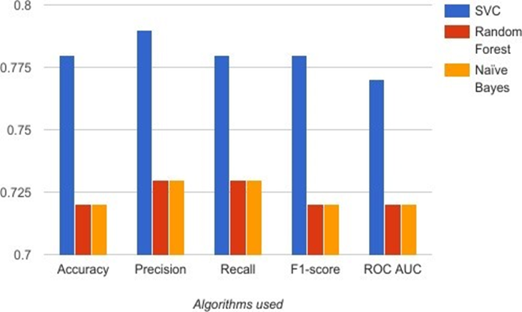

**Figure: 14.Boosted without feature selection.**

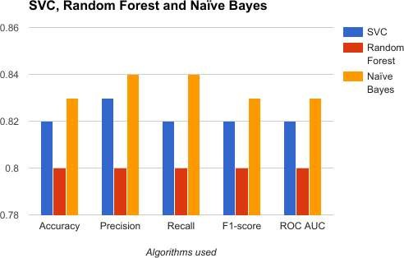

**Figure 15 Boosted algorithms with feature selection**

From the comparison of figure 14 and 15, Naïve Bayes performance increases signifi- cantly after feature selection and outperforms other algorithms if log loss is not taken into account.

Artificial Neural Network(ANN) is another algorithm used in this study. Performance metrics of ANN is in Table 11.

|  |  |  |  |  |  |  |
| --- | --- | --- | --- | --- | --- | --- |
| Algorithms used | Accuracy | Precision | Recall | F1-score | ROC  AUC | Log loss |
| ANN | 0.91 | 0.92 | 0.89 | 0.90 | 0.87 | 0.23 |

**Table 14, Evaluation of Artificial Neural Network**

ANN in Table 14, uses 3 hidden layers and also uses ‘adam’ algorithm as an optimizer.

ANN was parameter tuned with Keras machine learning library.

## **4.3 Comparison of Results**

From all the tables above, different algorithms performed better depending upon the situation whether cross validation, grid search, calibration and feature selection is used or not. Every algorithm has its intrinsic capacity to outperform other algorithm depend- ing upon the situation. For example, Random Forest performs much better with a large number of datasets than when data is small while Support Vector Machine performs better with a smaller number of data sets.

Performance of algorithms decreased after boosting in the data which was not feature selected while algorithms were performing better without boosting in not feature select- ed data. The performance of algorithms increased after boosting in the data which was feature selected while algorithm performance decreased after boosting in feature se- lected data. This shows the necessity that the data should be feature selected before applying boosting. For the comparison of dataset, performance metrics after feature selection, parameter tuning and calibration is used because this is standard process of evaluating algorithms.

In Table 13, performance metrics of classifiers are added except log loss because lower the log loss better is the classifier, so log loss is subtracted from the added performance metrics and then averaged. Average value of SVC, Random Forest and Naïve Bayes are 0.63, 0.59 and 0.63 respectively. This shows SVC and Naïve Bayes are performing on average.

In Table 14, ANN has highest classification accuracy. From the comparison of SVC or Naïve Bayes with ANN, ANN is the best classifier with 0.71 average value But ANN has a problem when applied in a clinical environment,because there is less space for the interpretation of the results. ANN works like a black-box, so it cannot be completely trusted before actually knowing how it is functioning.

# **SYSTEM ANALYSIS**

**CHAPTER 5**

**SYSTEM ANALYSIS**

**5.1 Existing System:**

* In the current existing system so many researchers working with data mining algorithms in different survey techniques.
* In these survey techniques they are using different sources but they are unable to analyze data with visualization techniques to identify the correlation between different attributes.
* Using limited techniques and they are unable to optimize by increasing efficiency.
* Increasing traffic congestion, air pollution, and fuel consumption
* Increase in use of less-adequate roads to avoid traffic signs
* Excessive delay due to time allocated by the traffic signals
* Some drivers disobey certain rules

**5.2 Proposed System:**

In our proposed system we are collecting data from different data sources and using advanced data visualization modules in python and analyze data with different visualization techniques and we are using different Machine learning Algorithms and evaluate increase performance and accuracy.

**5.2.1 Advanatges of Proposed System:**

* After each iteration, regression testing should be conducted. During this testing, faulty elements of the software can be quickly identified because few changes are made within any single iteration.
* It is generally easier to test and debug than other methods of software development because relatively smaller changes are made during each iteration. This allows for more targeted and rigorous testing of each element within the overall product.
* Customer can respond to features and review the product for any needed or useful changes.
* Initial product delivery is faster and also lowers the initial delivery cost.

\

# **SYSTEM DESIGN**

**CHAPTER 6**

**SYSTEM DESIGN**

**6.1 Modules:**

* User
* Admin
* System
* Database

**6.1.1 User:**

The client enter data or created using accident data from records . In many projects the end user is the one who needs the solution and gets the solution and that’s the total of their involvement. user is the term used for those people who actually use a product .For this project the users are public , apps and security .

**6.1.2 Admin:**

Admin to login and also collect data from UCI dataset. The UCI Machine Learning Repository is a collection of databases, domain theories, and data generators that are used by the machine learning community for the empirical analysis of machine learning algorithms. **6.1.3 System:**

It can illustrated how statistical method based on directed graphs and also print the result .

**6.1.4 Database:**

A database is a data structure that stores organized information.

**6.2 SYSTEM ARCHITECTURE:**

A system architecture or systems architecture is the conceptual model that defines the structure,behavior, and more views of a system. An architecture description is a formal description and representation of a system, organized in a way that supports reasoning about the structures and behaviors of the system.

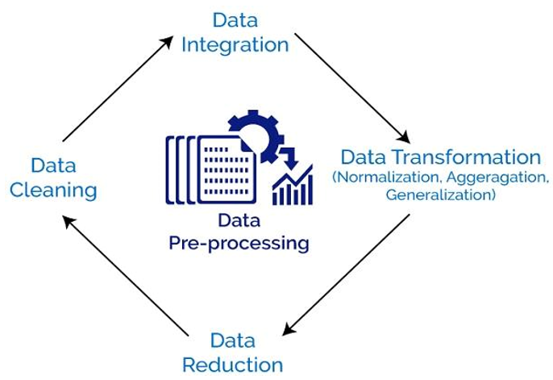

**Figure6.2: System Architecture**

**6.3 UML Diagrams:**

UML stands for Unified Modeling Language. UML is a standardized general-purpose modeling language in the field of object-oriented software engineering. The standard is managed and was created by the Object Management Group. The goal is for UML to become a common language for creating models of object oriented computer software. In its current form UML is comprised of two major components: a Metamodel and a notation. In the future, some form of method or process may also be added to; or associated with, UML.

The Unified Modeling Language is a standard language for specifying, Visualization, Constructing and documenting the artifacts of software system, as well as for business modeling and other non-software systems. The UML represents a collection of best engineering practices that have proven successful in the modeling of large and complex systems.

**GOALS:**

The Primary goals in the design of the UML are as follows:

1. Provide users a ready-to-use, expressive visual modeling Language so that they can develop and exchange meaningful models.
2. Provide extendibility and specialization mechanisms to extend the core concepts.
3. Be independent of particular programming languages and development process.
4. Provide a formal basis for understanding the modeling language.
5. Encourage the growth of OO tools market.
6. Support higher level development concepts such as collaborations, frameworks, patterns and components.
7. Integrate best practices.

**6.3.1 Architecture Design:**

* Design of a system consists of classes, interfaces, and collaboration.
* UML provides class diagram, object diagram to support this.
* Implementation defines the components assembled together to make a complete physical system.
* UML component diagram is used to support the implementation perspective.

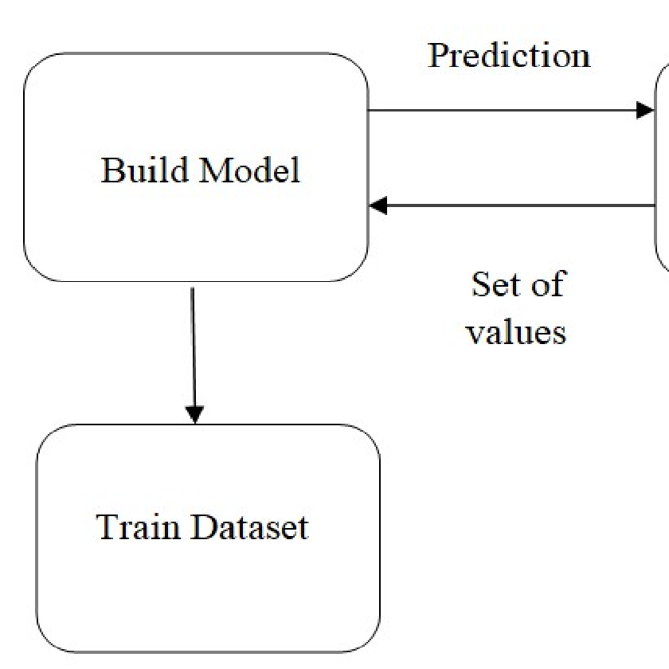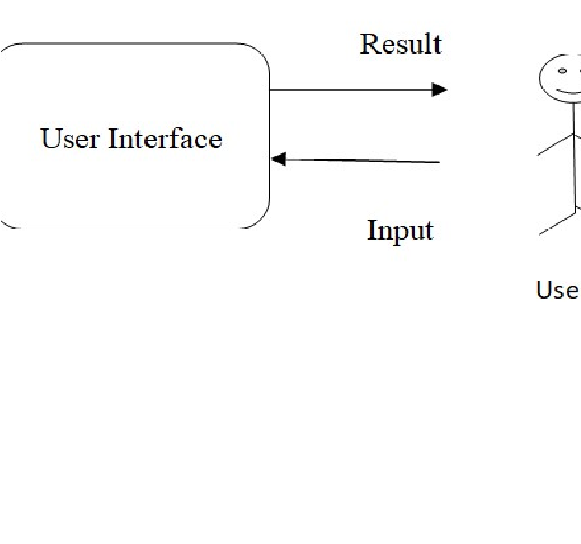

**Figure 6.3.1: Architecture Design**

**6.3.2 Activity Diagram**:

* Activity diagram is another important diagram in UML to describe the dynamic aspects of the system.
* Activity diagram is basically a flowchart to represent the flow from one activity to another activity.

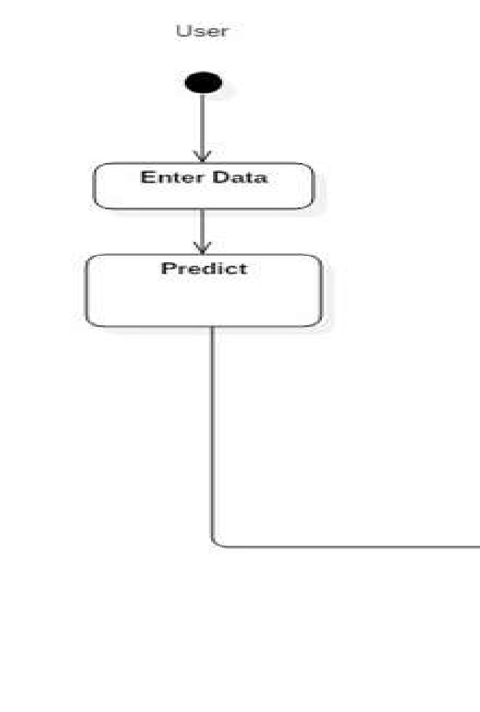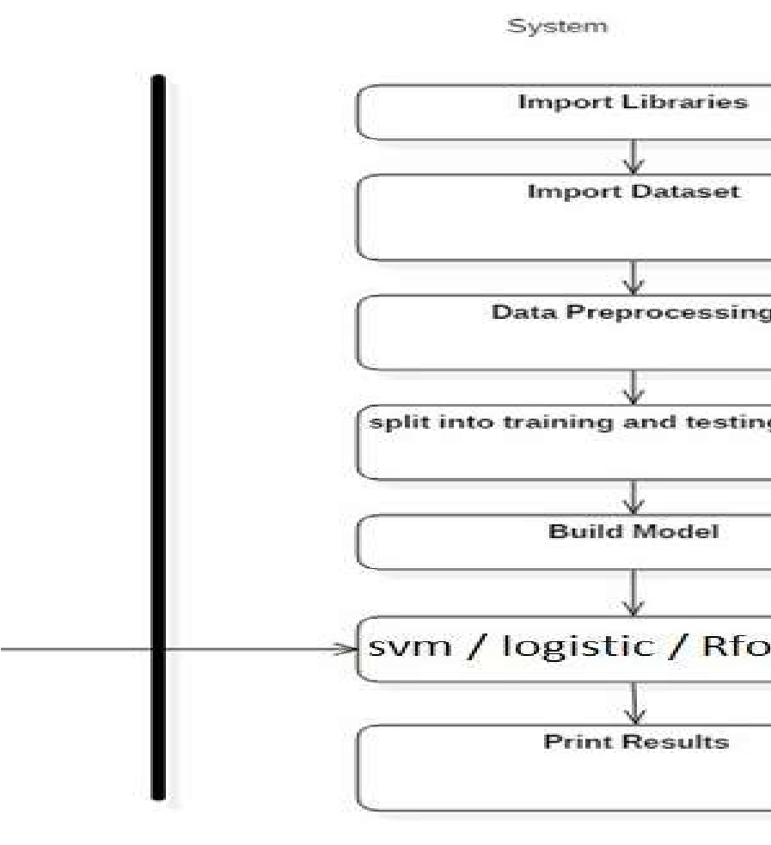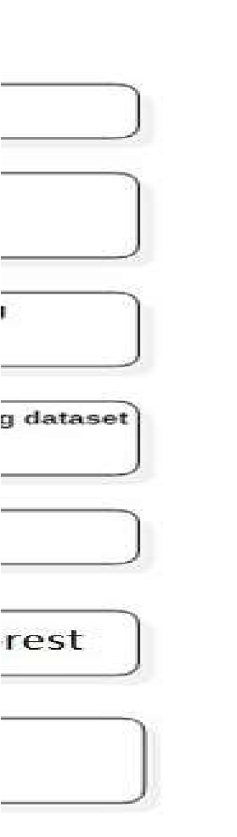

**Figure 6.3.2: Activity Diagram**

**6.3.3 Sequence Diagram:**

* + - * A sequence diagram is a type of interaction diagram because it describes how and in what order a group of objects works together.
      * These diagrams are used by software developers and business professionals to understand requirements for a new system or to document an existing process.
      * It is a construct of a Message Sequence Chart. Sequence diagrams are sometimes called event diagrams, event scenarios, and timing diagrams.

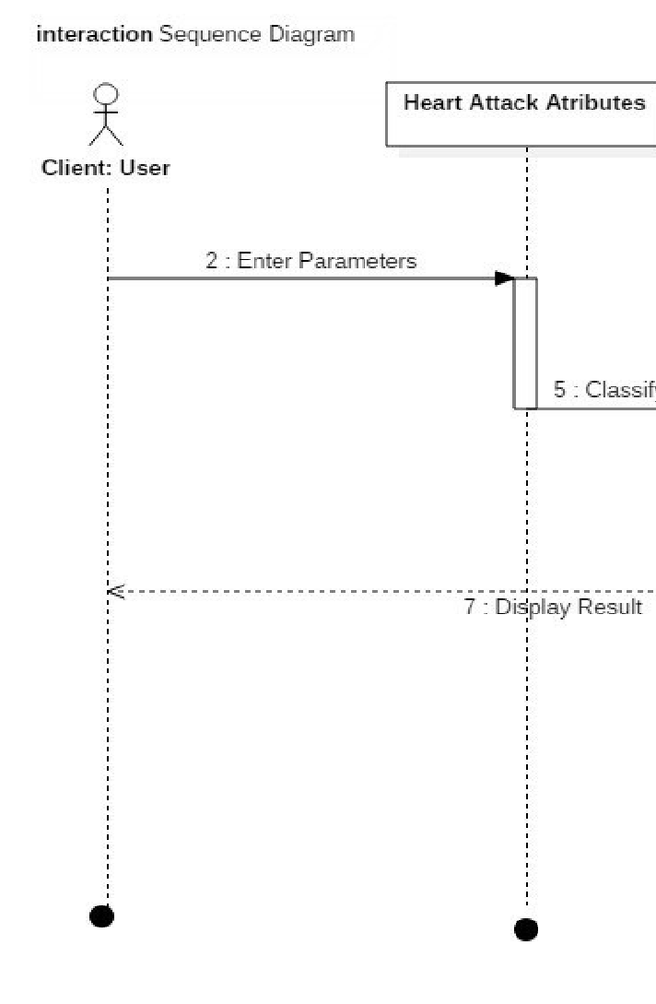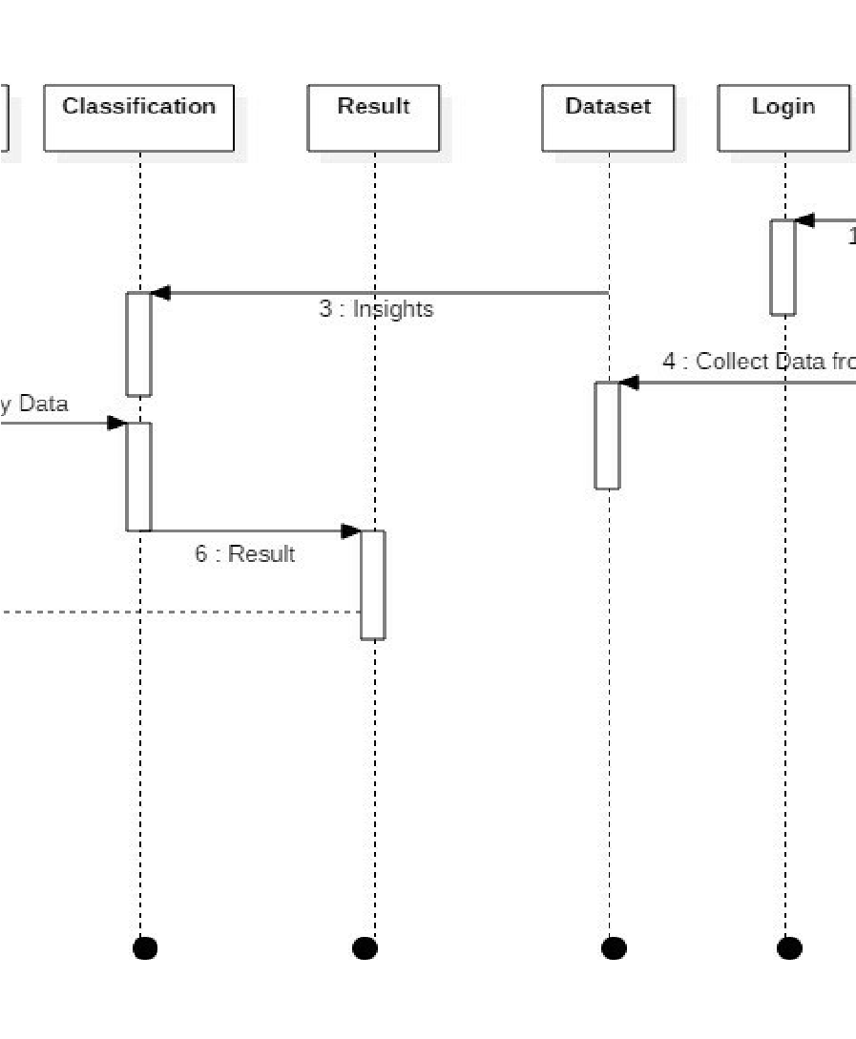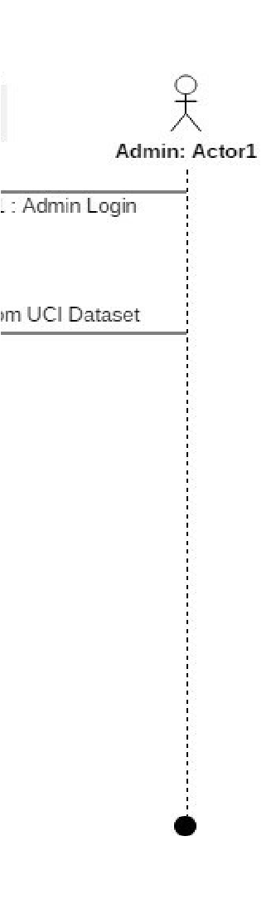

**Figure 6.3.3: Sequence Diagram**

**6.3.4 Interface Diagram:**

* + In UML modeling, interfaces are model elements that define sets of operations that other model elements, such as classes, or components must implement.
  + You can use interfaces in class diagrams and component diagrams to specify a contract between the interface and the classifier that realizes the interface.

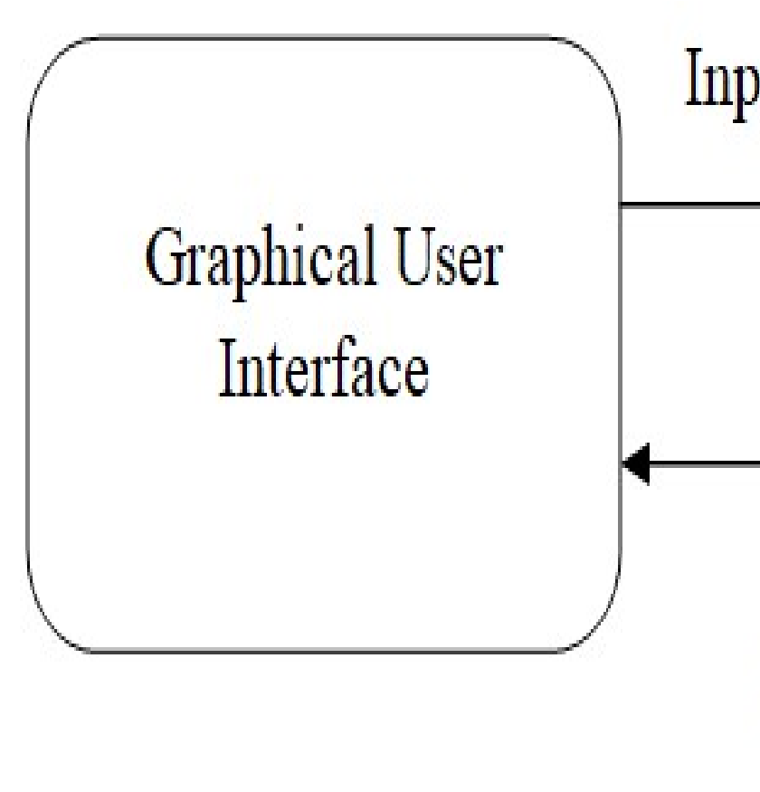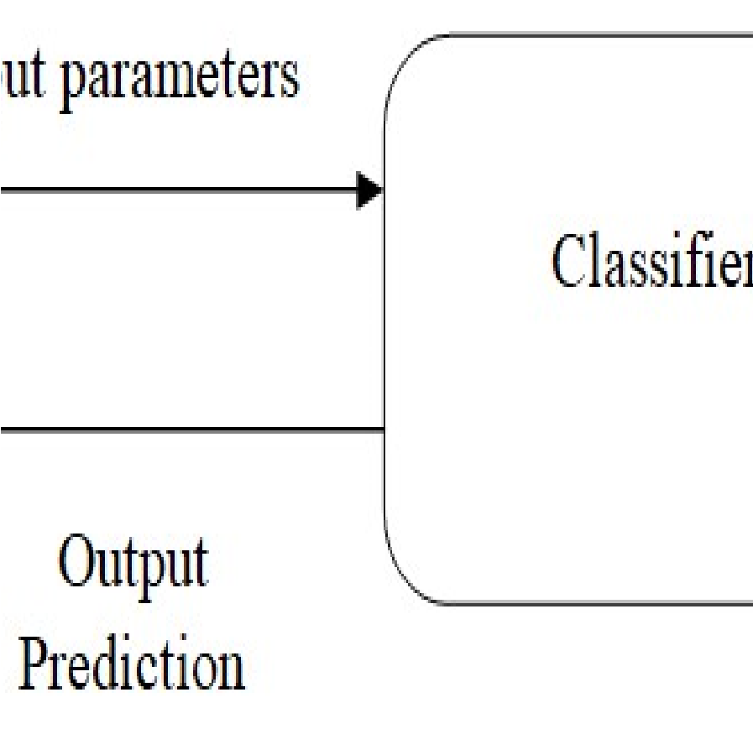

**Figure 6.3.4: Interface Diagram**

**6.3.5 State Machine Diagram:**

* + State machine diagram is a behavior diagram which shows discrete behavior of a part of designed system through finite state transitions.
  + State machine diagrams can also be used to express the usage protocol of part of a system.

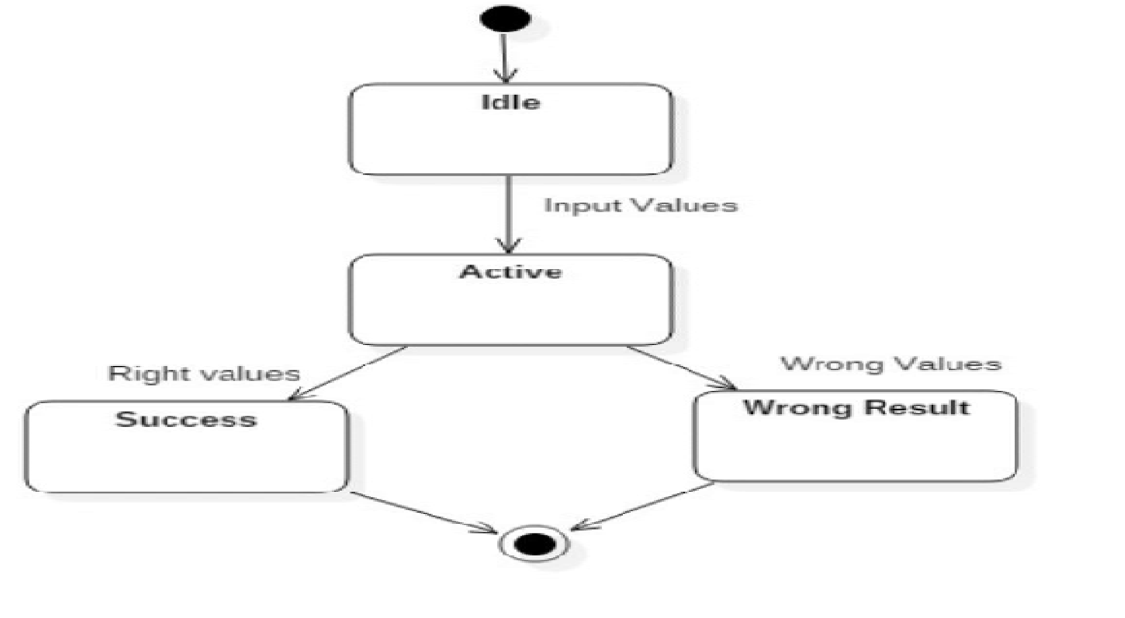

**Figure 6.3.5: State Machine Diagram**

# **SYSTEM REQUIREMENTS**

**CHAPTER 7**

**SYSTEMREQUIREMENTS**

**7.1 HARDWARE REQUIREMENTS:**

For developing the application, the following are the Hardware Requirements:

* System : i5 Processor
* Hard Disk : 500 GB.
* Input Devices : Keyboard, Mouse
* Ram : 4GB

**7.2 SOFTWARE REQUIREMENTS:**

For developing the application, the following are the Software Requirements:

* IDE : Anaconda Python, pandas, Jupyter Notebook
* Operating systems : Windows 7/10
* Coding language : Python

# **SYSTEM IMPLIMENTATION**

**CHAPTER 8**

**SYSTEM IMPLIMENTATION**

**8.1 MODULES DESCRIPTION:**

* Data Pre-Processing
* Classification with logistic regression

**8.1.1 Data Pre-Processing:**

Before actually applying the artificial intelligence algorithms to the data, it should be preprocessed. First of all it was decided to use only the statements themselves for classification purposes. This means that none o f the metadata provided is used for classification. The classification algorithm might actually be improved in the future by taking into account this metadata

**8.1.2 Classification with logistic regression:**

Logistic regression is a statistical method for analyzing a data set in which there are one or more independent variables that determine an outcome. The outcome is measured with a dichotomous variable (in which there are only two possible outcomes). For the cases when there are more than two labels, the strategy, which is called “One versus all”, is used. In this strategy every category is binary classified against its inverse (a fictional category that states that the example does not belong to the current category). The category with the highest score is picked as a result of a classification.

**8.2 Software and Languages used:**

**8.2.1 Jupyter**

Jupyter exists to develop open-source software. It is used for open-standards, and services for interactive computing across dozens of programming languages. It is an opensource web application that allows you to create and share documents and code live. Which is a very big advantage of Jupyter. It can be used for data cleaning and transformation, numerical simulation, statistical modeling, machine learning and much more. We used Jupyter to run the algorithm.

**8.2.2 Python**

Python is an interpreted, high-level and a general-purpose programming language. Created by Guido van Rossum and first released in 1991, Python has a design philosophy that emphasizes code readability, notably using significant whitespace. It is the most used programming language presently.

It provides constructs that enable clear programming on both small and large scales. The logistic regression in the system is implemented in jupyter and the algorithm is written in python language.

**8.2.3 HTML,CSS,JSCRIPT**

These are the most commonly used webpage development languages. The user interface designed for the prediction system is been developed using these languages. The website acts as an interface which takes the input those are the various constraints from the users and passes to the program to work upon.

**8.3 WORKING**

The working of the project is divided in to parts.

**8.3.1 Data Set Selection**

Data is the most import part when you work on prediction systems. It plays a very vital role your whole project i.e., you system depends on that data. So selection of data is the first and the critical step which should be performed properly, For our project we got the data from the government website. These datasets were available for all. There are other tons of websites who provide such data. The dataset we choose wad selected based on the various factors and constraints we were going to take under the consideration for our prediction system.

**8.3.2 Data Cleaning and Data Transformation**

After we have selected the dataset. The next step is to clean the data and transform it into the desired format as it is possible the dataset we use may be of different format. It is also possible that we may use multiple datasets from different sources which may be in different file formats. So to use them we need to convert them into the format we want to or the type that type prediction system supports. The reason behind this step is that it is possible that the data set contains the constraints which are not needed by the prediction system and including them makes the system complicated and may extend the processing time. Another reason behind data cleaning is the dataset may contain null value and garbage values too. So the solution to this issue is when the data is transformed the garbage values are replaced. There are many methods to perform that.

**8.3.3 Data Processing and Algorithm Implementation**

After the data is been cleaned and transformed it’s ready to process further. After the data has been cleaned and we have taken the required constraints. We divide the whole dataset int o the two parts that can be either 70-30 or 80-20. The larger portion of the data is for the processing. The algorithm is applied on that part of data. Which helps the algorithm to learn on its own and make prediction for the future data or the unknown data. The algorithm is executed in which we take only the required constraints from the cleaned data. The output of the algorithm is in ‘yes’ and ‘no’. It gives the error rate and the success rate.

**8.3.4 Output and User Side Experience**

After the prediction system is ready to use. The Website is developed for the user. The user just has to fill a form which consists of different options they need to select. They are like the type of climate, the type of vehicle and so on. Once the user submits the form the algorithm is triggered and the input given by the user is passed to the prediction system. The user is given how accident prone the road can be in percentage.

**8.4 Input And Output Design**

**8.4.1 Input Design**

The input design is the link between the information system and the user. It comprises the developing specification and procedures for data preparation and those steps are necessary to put transaction data in to a usable form for processing can be achieved by inspecting the computer to read data from a written or printed document or it can occur by having people keying the data directly into the system. The design of input focuses on controlling the amount of input required, controlling the errors, avoiding delay, avoiding extra steps and keeping the process simple. The input is designed in such a way so that it provides security and ease of use with retaining the privacy. Input Design considered the following things:

What data should be given as input?

* + - How the data should be arranged or coded?
    - The dialog to guide the operating personnel in providing input.
    - Methods for preparing input validations and steps to follow when error occur

**8.4.2 Objects:**

1.Input Design is the process of converting a user-oriented description of the input into a computerbased system. This design is important to avoid errors in the data input process and show the correct direction to the management for getting correct information from the computerized system.

2. It is achieved by creating user-friendly screens for the data entry to handle large volume of data. The goal of designing input is to make data entry easier and to be free from errors. The data entry screen is designed in such a way that all the data manipulates can be performed. It also provides record viewing facilities.

3.When the data is entered it will check for its validity. Data can be entered with the help of screens. Appropriate messages are provided as when needed so that the user will not be in maize of instant. Thus the objective of input design is to create an input layout that is easy to follow

**8.4.3 OUTPUT DESIGN**

A quality output is one, which meets the requirements of the end user and presents the information clearly. In any system results of processing are communicated to the users and to other system through outputs.

In output design it is determined how the information is to be displaced for immediate need and also the hard copy output. It is the most important and direct source information to the user.

Efficient and intelligent output design improves the system’s relationship to help user decisionmaking. Designing computer output should proceed in an organized well thought out manner; the right output must be developed while ensuring that each output element is designed so that people will find the system can use easily and effectively. When analysis design computer output, they should Identify the specific output that is needed to meet the requirements.

1. Select methods for presenting information.
2. Create document, report, or other formats that contain information produced by the system.
3. The output form of an information system should accomplish one or more of the following objectives. • Convey information about past activities, current status or projections of the Future.
   * Signal important events, opportunities, problems, or warnings.
   * Trigger an action.
   * Confirm an action.

# **SYSTEM TESTING**

**CHAPTER 9**

**SYSTEM TESTING**

Testing is that the debugging program is one amongst the leading crucial aspects of the pc programming triggers, while not programming that works, the system would ne'er turn out relate in Nursing output of that it had been designed .

Testing is best performed once user development is asked to help in characteristic all errors and bugs.

The sample knowledge are used for testing. It is not amount however quality of the information used the matters of testing .

Testing is aimed toward guaranteeing that the system was accurately relate in Nursing with efficiency before live operation commands Testing objectives:-

The most objective of testing is to uncover a bunch of errors, consistently and with minimum effort and time.

Stating formally ,we can say, testing may be a method of corporal punishment a program with intent of finding miscalculation.

A decent legal action is one that has likelihood of finding miscalculation, if it exists.The check is insufficient to find probably gift errors.

* 1. **TYPES OF TESTING**

Unit testing we have a tendency to test every module separately and integrate with the general system. Unit testing focuses verification efforts on the littlest unit of code style within the module. this is often conjointly called module testing.

The module of the system is tested individually. as an example the validation check is completed for variable the user input given by the user that validity of the information entered. it's terribly straightforward to search out error rectify the system. Every Module will be tested victimization the subsequent 2 Strategies: recording machine Testing and White Box Testing.

* + 1. **BLACK BOX TESTING**

Recording machine cheking may be a code testing techniques during which practicality of the code below test (SUT) is tested while not staring at the interior code structure

implementation details and data of internal ways of the code .This type of testing is predicated entirely on the code needs and specifications.

In recording machine Testing we have a tendency to simply concentrate on inputs and output of the package while not bothering concerning internal data of the code program.

The on top of recording machine will be any package you wish to check. For example, Associate in Nursing software like Windows, a web site like Google ,a information like Oracle or maybe your own custom application .

Under recording machine testing, you can check these applications by simply that specialize in the inputs and outputs while not knowing their internal code implementation.

**Types of Black Box Testing :**

There are many varieties of recording machine Testing however following ar the outstanding ones. Functional testing: This recording machine testing kind is said to purposeful needs of a system; it's done by code testers.

Non-Functional testing: This sort of recording machine testing isn't associated with testing of a selected practicality, however non-functional needs like performance, measurability, usability.

Egression Testing: Regression testing is completed once code fixes, upgrades or the other system maintenance to visualize the new code has not affected the prevailing code.

**9.1.2. WHITE BOX TESTING**

White Box Testing is that the testing of a code solution's internal committal to writing and infrastructure.

It focuses totally on Traffic Redundancy Elimination ngthening security, the flow of inputs and outputs through the applying, and rising style and value.

White box testing is additionally called clear, open, structural, and glass box testing. It is one amongst 2 elements of the "box testing" approach of code testing.

**System Testing:**

Once the individual module testing is completed, modules are assembled and integrated to perform as a system. The top down testing, that began from higher level to lower level module, was allotted to visualize whether or not the whole system is playacting satisfactorily. There are 3 main types of System testing:

* + - 1. Alpha Testing
      2. Beta Testing and
      3. Acceptance Testing.

Alpha Testing:

This refers to the system checking that's allotted by the test team with the Organization.

Beta Testing:

This refers to the system testing that's performed by a particular cluster of friendly customers.

Acceptance Testing:

This refers to the system testing that's performed by the client to see whether or not or to not settle for the delivery of the system.

# **OUTPUT SCREENS**

**CHAPTER 10**

**OUTPUT SCREENS**

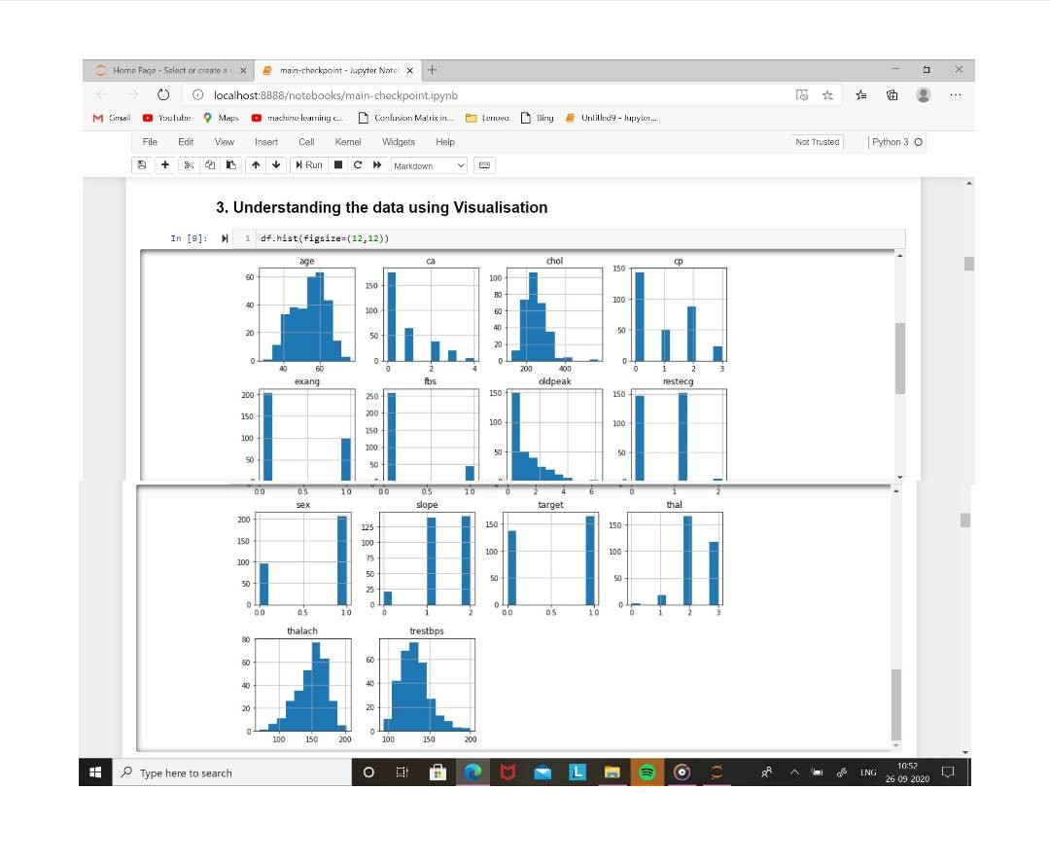**Fig 16: Understanding the data Using Visualisation**

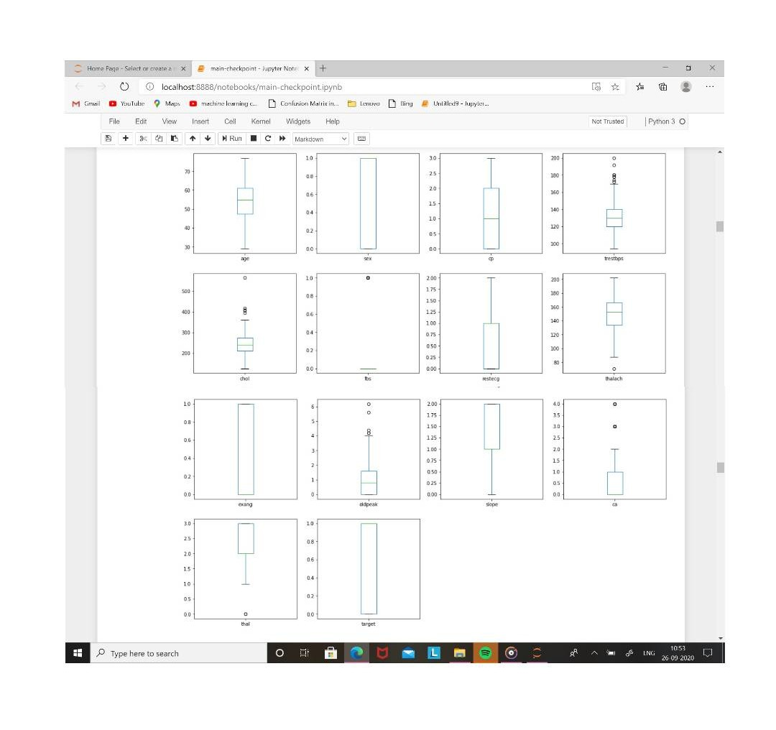**Fig 17: Overfitting using Boxplot on using Matplotlib**

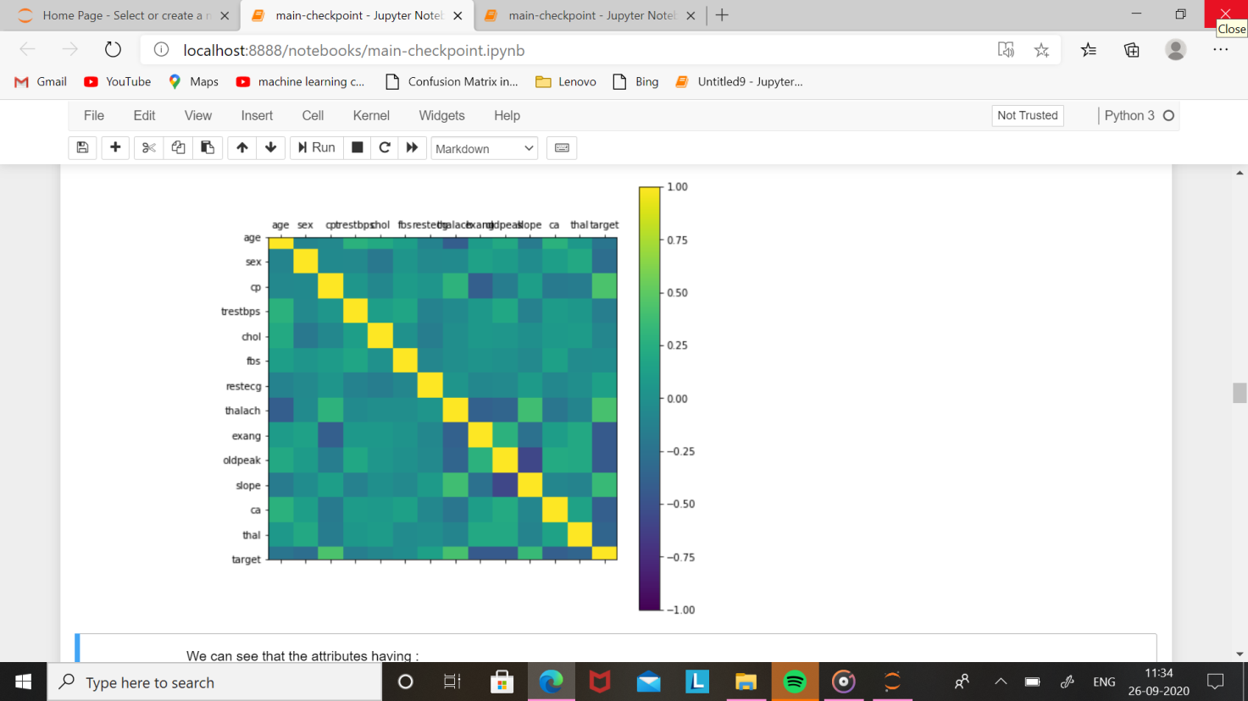

**Fig 18: Correlation Matrix Using Matplotlib**

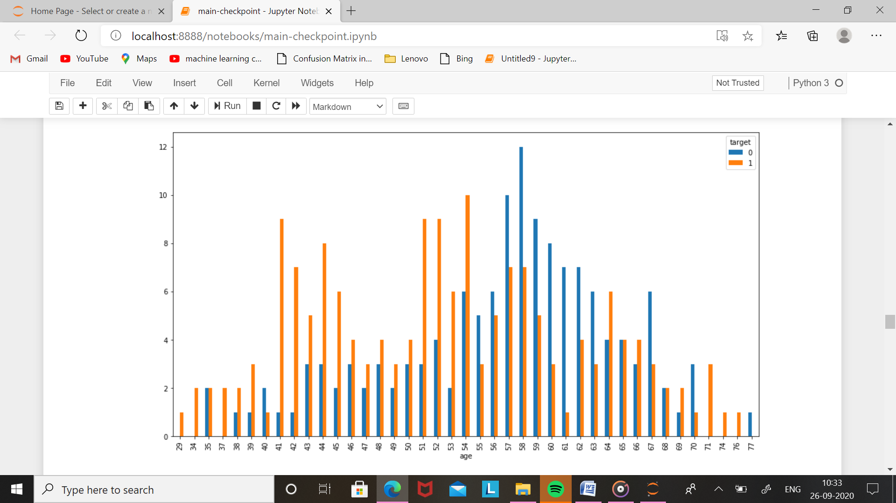

**Fig 19: Age with barplot on matplotlib**

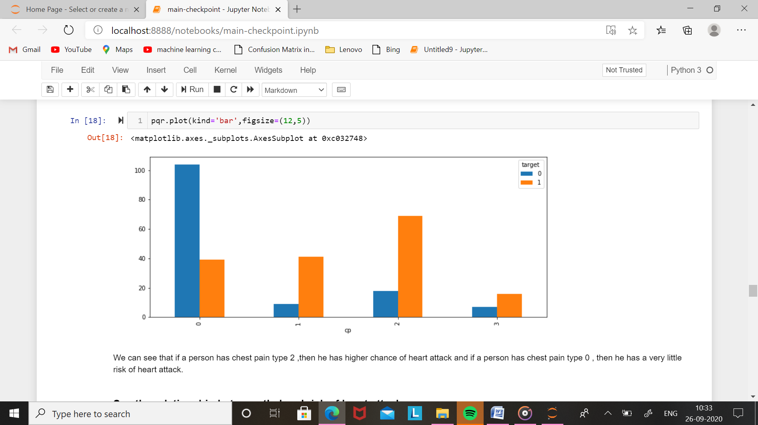

**Fig 20: barplot on age with matplotlib**

# Screenshot (8).png

**Fig 21: barplot on heart attack with matplotlib**

# Screenshot (9).png

**Fig 22: Confusion Matrix using on matplotlib**

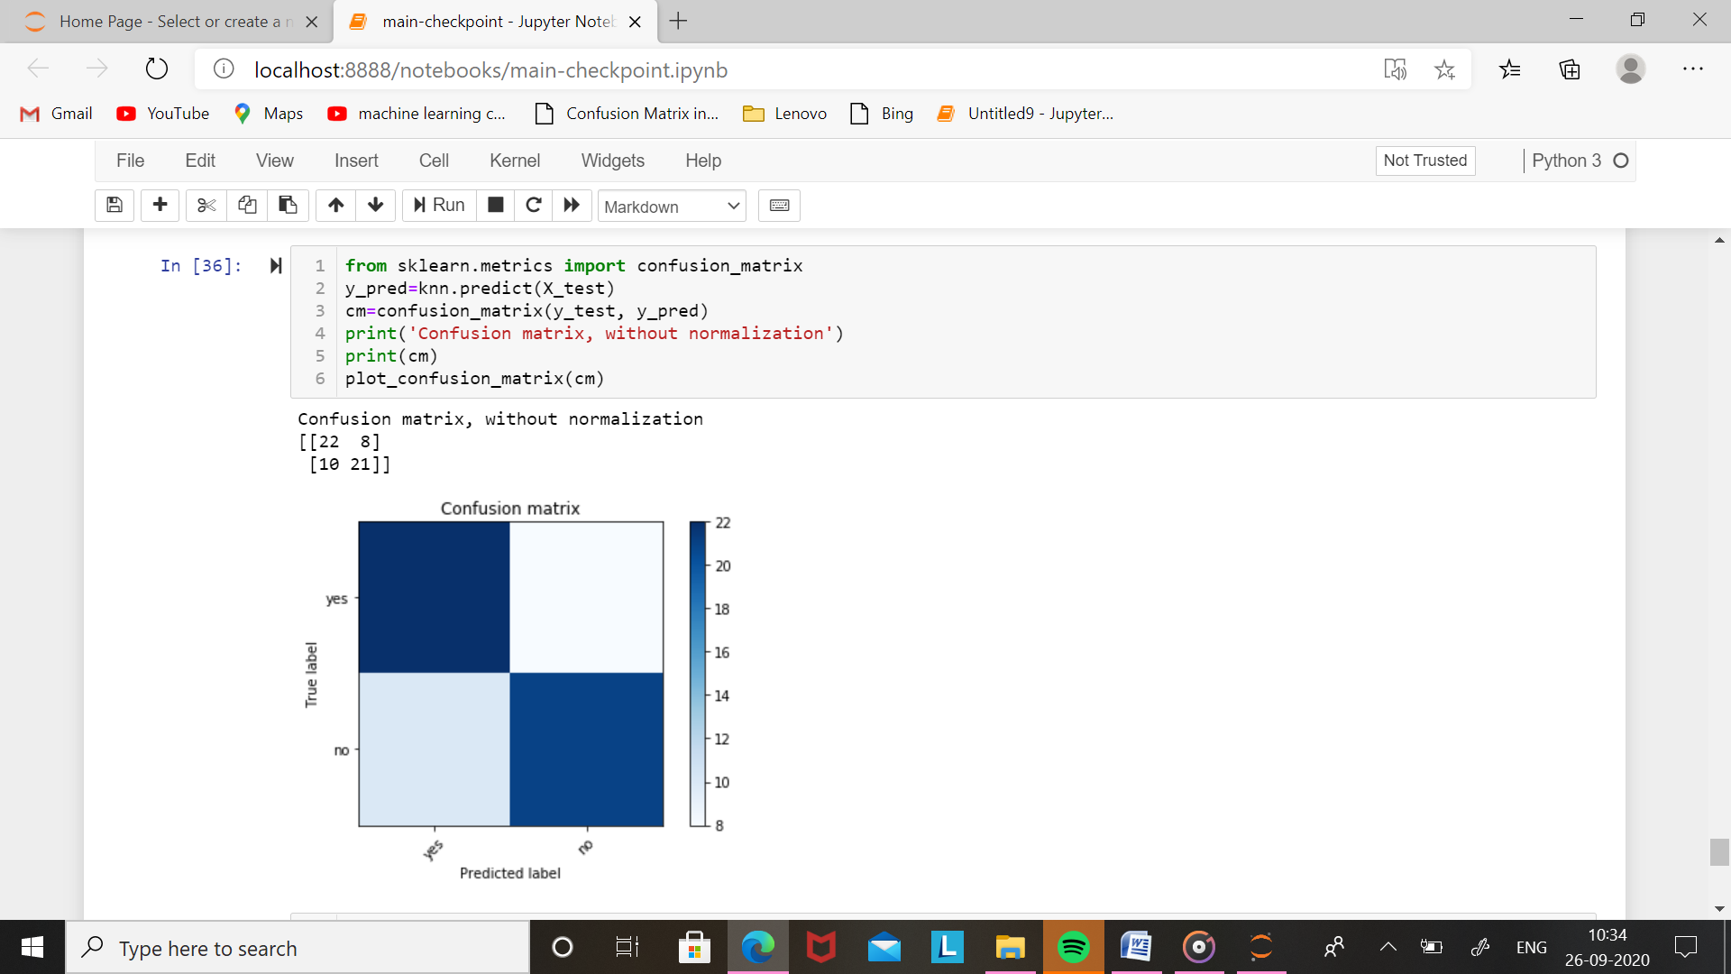

**Fig 23: confusion matrix on matplotlib using accuracy**

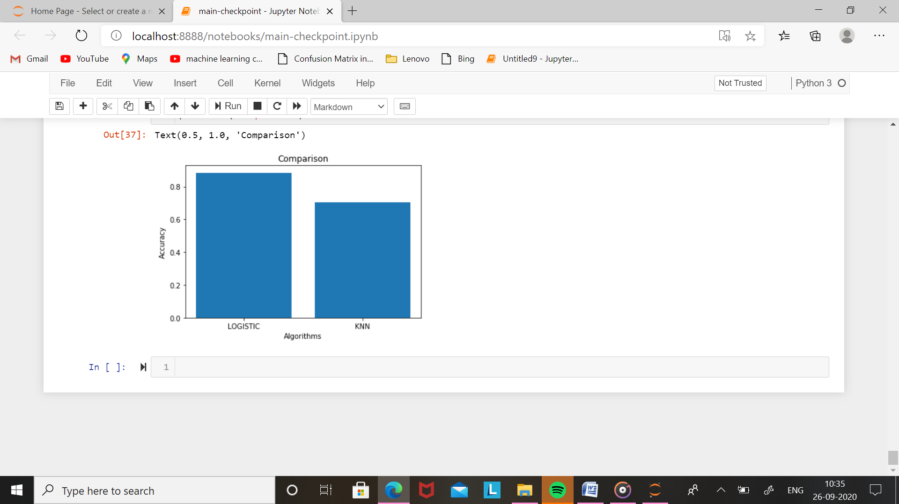

**Fig 24: Algorithams on Barplot using Matplotlib**

# **CONCLUSION**

**CONCLUSION**

The goal of the project was to compare the algorithms with different perfomance metrics using machine learning. All data were pre-processed and used for the prediction on the test. Every algorithm performed better in some situation and worse in an other. SVC, and ANN and Naïve Bayes are the likely models to work best in the dataset used in this study.

To be able to diagnose the heart disease accurately using machine learning has many significances. Different devices can be manufactured which will monitor the heart relat- ed activities and diagnose the disease. These devices will prove to be helpful where heart disease experts are not available. With further research machine learning can also be used to diagnose the heart disease before the human experts can do.

One of the main achievements of this project was that project helped to understand the algorithms better. When tested through various situations, the algorithms performed differently which helped me to understand the algorithm’s working mechanism. This thesis can be first learning step in heart disease diagnosis with machine learning and it can be extended further for future research. There are several limitations to this study primarily the knowledge base of the author, secondly, the tools used in this study such as processing power of the computer and thirdly the time limitation available for the study. This type of study requires state-of-art resources and expertise in respective domains.

# **REFERENCES**

**REFERENCES**

1. The Atlas of Heart Disease and Stroke [online].

URL: http://www.who.int/cardiovascular_diseases/resources/atlas/en/Accessed 26 February 2017.

1. CSC Infographic Big Data [online].

URL:http://assets1.csc.com/insights/downloads/CSC_Infographic_Big_Data.pdf Accessed 26 February 2017.

1. Machine Learning Techniques for Multimedia Case Studies on Organization and Retrieval Cord, M.: Cunningham, P, (Eds) 2008, XVI, 289 p, Hardcover
2. Business Dictionary [online].

URL: http://www.businessdictionary.com/definition/regression.htmlAccessed 26 February 2017.

1. Max Bramer, Principles of Data Mining. 2nd ed. Springer; 2013
2. Robert A Wilson. The MIT Encyclopaedia of Cognitive Sciences. MIT Press; 1999
3. Ethan Alapydin. Introduction to Machine Learning, 2nd ed. Cambridge Massa- chusetts, MIT Press:2010.
4. Md Rahat Hossain, The Combined Effect of Applying Feature Selection and Pa- rameterOptimzation on Machine Learning Techniques for PowerPredic- tion. American Journal of Energy Research 2013; 1(1): 7-16.
5. Gareth James. Introduction to Statistical Learning. New York, Springer; 2013.
6. Ömer Cengiz Çelebi. Principal Component Analysis [online]. 26 February 2002 URL:http://www.byclb.com/TR/Tutorials/neural_networks/ch5_1.htm Accessed 26 February 2017.
7. Lindasay I Smith. A tutorial on Principal Component Analysis [online].

URL:

http://www.cs.otago.ac.nz/cosc453/student_tutorials/principal_components.pdfAccessed 8 March 2017.

1. Laetitia Van Cauwenberge. Top 10 Machine Learning Algorithms [online].Data

Science Central; 6 December 2015

URL:http://www.datasciencecentral.com/profiles/blogs/top-10-machine-learning- algorithms

Accessed 26 February 2017.

1. Shai Shalev-Shwartz, Shai Ben-David. Understanding Machine Learning. New York, Cambridge University Press; 2014.
2. Michael Luk. K-Nearest Neighbour and Dynamic Time Wrapping [online]. De- vices using DTW and KNN; 16 July 2016

URL:https://sflscientific.com/case-studies/2016/6/4/time-series-analysis-fitbit-using-dtw-and-knn

Accessed 26 February 2017.

1. Introduction to Support Vector Machines [online]. Open-CV Documentation; 7 March 2017 URL:http://docs.opencv.org/2.4/doc/tutorials/ml/introduction_to_svm/introduction_to_svm.html

Accessed 26 February 2017.

1. Robert Scaphire. Explaining AdaBoost [online].

URL:http://rob.schapire.net/papers/explaining-adaboost.pdf Accessed 26 February 2017.

1. Hastie, Tibshirani, Friedman. The Elements of Statistical Learning. 2nd ed.

Springer Series in Statistics; 2009

1. Computer Science Department Darmouth College. A Basic Introduction to Neural Networks [online].

URL:https://www.cs.duke.edu/brd/Teaching/Previous/AI/Lectures/NN/neural.htmlAccessed 26 February 2017

1. Thomas G. Tape.The Area Under ROC Curve [online]. University of Nebraska

Medical Center; 17 December 2016 URL: http://gim.unmc.edu/dxtests/roc3.htmAccessed 26 February 2017.

1. Log Loss [online].

URL: http://scikitlearn.org/stable/modules/generated/sklearn.metrics.log_loss.html Accessed 26 February 2017.

1. Probability Calibration [online].

URL: http://scikit-learn.org/stable/modules/calibration.htmlAccessed 26 February 2017

1. Yin. Case Study Research: Design and Methods (Applied Social Research

Methods). 5th edition. Los Angeles, Sage Publications; 2013

1. Burns N, Grove K. The Practice of Nursing Research: Conduct, Critique and

Utilization. 5th ed. St. Louis, Elsevier Saunders; 2005

1. UCI Machine Learning Repository [online]. URL:http://archive.ics.uci.edu/ml/about.html Accessed 26 February 2017.
2. UCI Machine Learning Repository [online].

URL:https://archive.ics.uci.edu/ml/machine-learning-databases/heart- disease/heart-disease.names Accessed 26 February 2017.

1. Python Programming Documentation [online]. URL:https://www.python.org/about/ Accessed 26 February 2017.
2. Numpy Documentation [online]. URL:http://www.numpy.org/Accessed 26 February 2017.
3. Pandas Documentation [online]. URL :http://pandas.pydata.org/ Accessed 26 February 2017
4. Michael Waksom. An Introduction to Seaborn [online].

URL :http://seaborn.pydata.org/introduction.html

Accessed 26 February 2017

1. Fabian Pedregosa. Scikit-learn: Machine Learning in Python [online].

URL: http://jmlr.csail.mit.edu/papers/v12/pedregosa11a.html